

Feel

Luckv?

ff

You wouldn’t dream of leaving your success to chance. You know that making it in the safe and vault industry requires hard work, continual improvement of techniques, and constant research of the latest products and tools.

Your best bet to excel in all these areas is SAFETECH ’99 where you can save your luck for the casinos, and get down to business viewing the latest products, talking with the manufacturers, and training in the latest methods of safe and vault technology.

//

Make your plans now to attend  
SAFETECH ’99 May 3-8, 1999  
in Las Vegas, NV.



0

0

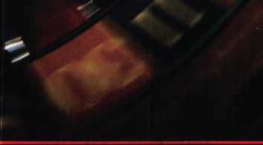

**LAS VEGAS, NV < MAV 3-B**

Contact:

Safe and Vault Technicians Association

3003 Live Dak Street

Dallas, TX 75204

214.827.7233

214.827 1810 fax

email: [convtion@anet-dfw.com](mailto:convtion@anet-dfw.com)

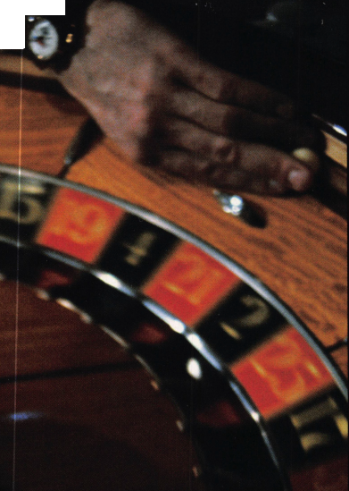

**Spotting a fresh face  
could get you some great stuff.**

Facing Facts

Do you know what happens when you sponsor an individual for membership in your national association? You strengthen the voice of the industry and you help another locksmith along the road to complete professionalism.

As an added bonus, for each member you sponsor during 1999, you will receive $40 in Convention Bucks (good for ALOA registration, classes, goods and services at ALOA '99 or ALOA 2000), and an entry in a drawing for one of several incredible prizes, some valued up to $2,199!! You could be the winner of a: Rytan RY100 Duplicating Machine, HPC1200 Blitz Code Machine, Silca Bravo USA Duplicating Machine, Framon Sidewinder Duplicating

Machine, JET ETD-1 Transponder Key Decoder Kit, Silca RW2 Transponder REader/Duplicator, High Tech Tools Pro Lockout Kit or a DeWalt 18V 1/2" Cordless Hammerdrill and Reciprocating Saw Set!

Keep An Eye Out

Everybody wins when you spot that next ALOA member. Let's put our noses to the grindstone and enter the next century with a larger, stronger membership. You can get a copy of ALOA's membership application on our web page at [www.aloa.org](http://www.aloa.org) under "Joining ALOA,"or by calling 1.800.532.2562. Sign up a friend today, and send us their photo so that we can include them in future ads!



Contents

Features

February

- 99 U

The Cover:

Got a case of “technophobia? Education can help you conquer your fears of electronic locksmithing. Mr. Electricity will get you started!

Art direction/design Valerie Rowe

Graphic design Lori Brennan

President’s Journey

By Dallas Brooks

11

Legislative Comment

A state-by-state update of what’s happening

on the legislative front.

By Tim McMullen

14

ALOA Board Nominations

The deadline for ALOA Board nominations will be here before  
you know it. Find out everything you need to know right here.

16

Mister Electricity

Thinking of getting into electronic locksmithing? Ed Hite  
I may spark your interest on the matter.

By Mike Emery

Farewell to the Father of Manipulation

Few men could have accomplished what Harry C. Miller did. His name remains synonymous with the safe and lock world. Keynotes salutes this legendary figure whose vision changed the industry.

By Mike Emery

Access Control with a Little Help From Ma Bell

Our expert dials into the field of electronic telephone access.

By Paul Chandler, CRL

Motorcycle Locksmithing: Suzuki

Born to be wild? An easy rider? Our motorcycle specialists explore the workings of the Suzuki.

By Ray D’adamo, CML and Tina D’adamo, CRL

27

Puttin’ On “The Blitz”

Get the facts on the HPC 1200CMB “The Blitz” Code Machine!

By Sal Dulcamara, CML

32

IC Tools from PRO-LOK

Find out what’s at the core of these new IC tools!

By Sal Dulcamara, CML

34

The Shop Van, Part II

Your company vehicle does more than just take you to service calls. Learn how to effectively make your shop van an advertising tool.

By Michael A. Ferrill

-i

**Volume 45, Issue**

**rtments**

6

Upcoming Events

8

Security Marketplace

10

Applicants for membership  
Scheduled for clearance March 1

12

Core

The people speak and Sentry listens!

43

Authors in This Issue

Keynotes

February 1999

44

Back Page

■

kWl

**vertisin**

36

Associate Members

42

Ad Index

40

Classifieds

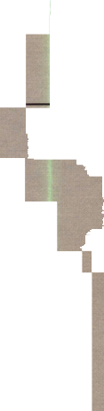

[david@aloa.ioflfice.com](mailto:david@aloa.ioflfice.com)

Editorial Advisor Advertising Sales

Contributing Authors

ALOA Professional Staff Executive Director

Operations Manager

Receptionist Comptroller Finance Coordinator Meetings Manager

Meetings Coordinator Government Affairs Manager

PRP/Education Manager

Education Assistant Membership Manager

Membership Coordinator

Chapters & Regional Associations Liaison

John D. Cannon, CML [jdcannon@worldnet.att.net](mailto:jdcannon@worldnet.att.net) Marvin Diamond Lionheart Publishing (770) 431-0867, ext. 208 Jerome V. Andrews, CML Paul Chandler, CRL Claire Cohen, CML Brian Costley, CML, CMS Bob De Weese, CPL Ray D’Adamo, CML Sal Dulcamara, CML James Glazier, CML Daniel Graffeo, CRL, CMS Wayne Gurnee, CRL A.J. Hoffman, CML Ken Holmlund, CRL Ray Lusk, CML Mark Ohno Randy Simpson, CML Robert Stafford, CPL Dave Thielen, CML

Charles W. Gibson, Jr., CAE [charlie@aloa.ioflfice.com](mailto:charlie@aloa.ioflfice.com) Mary May

[mary@aloa.ioffice.com](mailto:mary@aloa.ioffice.com) Shenika Theus Kathy J. Romo Janelle Vergara Jessica Smith [jessica@aloa.ioffice.com](mailto:jessica@aloa.ioffice.com) Janelle Vergara Tim McMullen [tim@aloa.ioffice.com](mailto:tim@aloa.ioffice.com) David Lowell, CML, CMS [david@aloa.ioffice.com](mailto:david@aloa.ioffice.com) Ashley Spencer Brandon Durrett [brandon@aloa.ioffice.com](mailto:brandon@aloa.ioffice.com) Jackie Arnett [jackie@aloa.ioffice.com](mailto:jackie@aloa.ioffice.com)

Tim McMullen [tim@aloa.ioflfice.com](mailto:tim@aloa.ioflfice.com)

Additional contact information for the ALOA Board and most Keynotes authors are available through “Locksmith Search" on the ALOA website- [www.aloa.org](http://www.aloa.org) or by contacting the ALOA office at 3003 Live Oak Street; Dallas, TX 75204; (800)532-2562; FAX (214) 827-1810; e-mail [aloa@aloa.org](mailto:aloa@aloa.org).



Mission Statement: The Associated Locksmiths of America, Inc. is dedicated to enhancing the professionalism, education and ethics among locksmiths and those in related sectors of the physical security industry. With approximately 10,000 members in the United States, Canada and the freeworld, ALOA is poised to help members obtain the knowledge, the strength, and the confidence to perform their role in the physical security field with pride and dignity. But it is only through active involvement and participation that ALOA can fully achieve its potential-and can help members to achieve theirs.

Policies: Keynoted is the official publication of the Associated Locksmiths of America, Inc. (ALOA). Keynoted acts as a moderator without approving, disapproving, or guaranteeing the validity or accuracy of any data, claim, or opinion appearing under a byline or obtained or quoted from an acknowledged source. The opinions expressed by the authors do not necessarily reflect the official views of ALOA. Also, appearance of advertisements and new products or service information does not constitute an endorsement of products or services featured by the Association. The Association does not accept responsibility for the inaccuracy of any data, claim, or opinion appearing in this publication, due to typographical errors on the part of the authors, Association staff or its agents. Editor’s Note: This publication is designed to provide accurate and authoritative information in regard to the subject matter covered. It is provided and disseminated with the understanding that the publisher is not engaged in rendering legal or other professional services. If legal advice and other expert assistance is required, the services of a competent professional should be sought.

Authors’ Payment: Payment for eligible submissions to Keynotes will be based on the following criteria: topic, time spent and past contributions. Authors who regularly submit to Keynotes are generally paid a higher rate. The latter is especially true of authors who write to fit specific editorial needs and submit said copy by Keynotes deadlines. As a general guideline: Average payment for a 750 word, business or ‘light’ technical article would be $200. Payment for a 1500 word article involving significantly higher time and research efforts would be $400.

Payment will not be offered for articles submitted by ALOA employees or members of the ALOA Board of Directors (unless material is of a technical nature), nor for articles submitted by a company that promote that company’s products or services. ALOA reserves the right not to pay for articles submitted by an individuals) that promote a particular company’s products or services.

Disclaimer: The Associated Locksmiths of America, Inc., (ALOA), reserves the right to refuse any article for any reason. Additionally, ALOA reserves the right to edit amend or modify any article submitted for publication in order to preserve technical accuracy, clarity, fairness or grammatical correctness. ALOA will make the best efforts to notify the author of any changes. The extent of ALOA’s liability for any article or information contained therein will be a notice of correction or retraction in the next possible issue.

Keynoted (ISSN 0277 0792) is published monthly except for the combined June/July issue by The Associated Locksmiths of America, Inc., 3003 Live Oak St., Dallas, TX 75204-6186. Telephone: (214) 827-1701; FAX (214) 827-1810; e-mail [aloa@aloa.org](mailto:aloa@aloa.org). Subscription rates for members-$15.00 per year. Second class postage paid at Dallas, Texas. POSTMASTER: Send address changes to: Keynotes, 3003 Live Oak St., Dallas, TX 75204-6186. © Copyright 1999, All rights reserved. No part of the contents may be reproduced or reprinted in any form without prior written permission of the publisher.

Dallas C. Brooks (334) 826-8990

Secretary

John D. Cannon, CML (703) 960-6413

Directors, Northeast

James H. Glazier, CML (301) 831-5454 John G. Magee, III

1. 845-3434 William L. Young, CML
2. ) 647-5042

Directors, Southeast

Jeffrey S. Nunberg, CML, CMS (305) 324-8800 Donald R. Rule, CML (601) 324-2658

Directors, North Central

Mark E. Blum. CML, CPS (517) 482-5809 John J. Greenan (773) 486-2030

Director, South Central

Randy L. Simpson, CML (713) 780-7026

Directors, Southwest

Gordon Racine, CML (719) 384-4707 John I. Shandy, CML (303) 774-9791

Director, Northwest

Scott Henke, CRL, CPS (907) 248-3785

Director, Associate Members

Judd Penske (800) 634-5465

Non-voting directors

Jerome V. Andrews, CML (216) 252-9586 Steve G. Engel, CML, CPP (920) 731-5400

Trustees

David M. Lowell,CML, CMS (800) 532-2562 Brack H. Camp, CML (770) 455-6244 Henry H. Printz, CML (973) 538-2737 Leonard J. Passarello, CPL (416) 752-7210 Edwin Toepfer, RL (416) 225-5589

Chairmen of International Affairs

Laurence P. Mills/Australia (129) 958-0445 Hans Mejlshede, CML/Europe FAX (453) 139-1004

Past Presidents

1995-1997 David Lowell. CML, CMS 1993-1995 Brack Camp, CML 1991-1993 Henry Printz, CML 1989-1991 Evelyn Wersonick, CML, CPS 1987-1989 Leonard Passarello, CPL 1985-1987 Joe Jackman, CML 1983-1985 Stanley Haney, CPL 1981-1983 Louis LaGreco, CPL 1979-1981 John Kerr, RL 1977-1979 Clifford Cox, CML 1974-1977 Charles Hetherington 1972-1974 Gene Laughridge 1970-1972 William Dutcher, RL 1968-1970 Constant Maffrey, RL 1966-1968 Harold Edelstein, RL 1964-1966 William Meacham 1962-1964 Robert Rackliffe, CPL 1960-1962 Edwin Toepfer, RL 1956-1960 Ernest Johannesen

February 1999

Keynotes

with Dallas Brooks

_

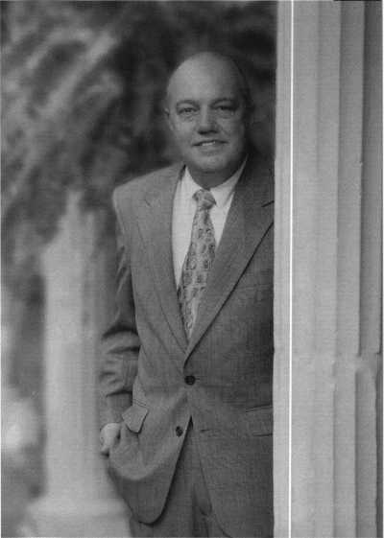

-J

With all the chilly weather that’s been sweeping the country, I’m hoping that all of you have stayed warm and healthy this winter (particularly, you members in the midwest). But spring is almost here, meaning the deadline for Board nominations is upon us.

The exact deadline is April 1, 1999 and there are six regional director positions open as well as the position of president. The regional director positions that are available are as follows:

Southeast two directors

North Central two directors

Southwest two directors

This is an excellent opportunity to see your region represented by a candidate you strongly endorse. It’s also a good chance to place a new and exciting face in the president’s seat. Don’t forget, you need not be an existing Board member to run. For more details on the nomination process as well as a nomination form and petition, see pages 14-15 in this issue of Keynotes.

Aside from Board elections, another important aspect of ALOA that’s seeing some changes is in the realm of education. One of our priorities is organizing all of the classes that will be held at ALOA ‘99 in Cincinnati. Education manager and Keynotes’ technical editor David Lowell informs me that there are close to 70 full-day classes and around 30-35 half-day classes. There will even be extra classes that will be given the day after the convention on Sunday, August 1. It will be a bonus of sorts for those who were unable to attend the convention but can make it to this day of classes or those who want to stay an extra day. This will also allow those whose work schedule only permits them to attend ALOA ’99 on its final weekend to round out their experience by having events Friday through Sunday. We’re currently working with various instructors to make sure that many of the classes will be PRP certified, which I’m certain is of interest to many of you. This way, attendees can take the PRP exam for the particular class they enroll in. It will also be possible for people to take as many classes that are PRP certified and if the exams are passed, all credits will accumulate, even if you have not passed the mandatory exam. Of course, you will not receive your designation until that mandatory requirement is successfully completed, but you will receive credit for all other electives taken.

Speaking of the PRP, I’m pleased to say that we’ll be able to offer it in more areas now. Thanks to assistance from local chapter officers serving as proctors, testing is all the more available for all of our members. Start thinking about the classes you’d like to take at ALOA ’99 because it will be here before you know it. Likewise, don’t forget about the nomination deadline on April 1.

Until next time, stay warm during these last months of winter. Talk to you in spring!

8JtL

Dallas C. Brooks President



Keynotes

February 1999

The Brightest

And The Best.

|  |  |
| --- | --- |
| Kwok-kei Leung | 170 |
| Henry Raymond | 93 |
| Toshihiro Asano | 81 |
| Stewart Levine, CML | 67 |
| Mary Ohmit, CPL | 64 |
| Charles Robertson, CML | 63 |
| Ynrikn Yanai | 61 |
| Jack Hobin, CPL | 51 |
| Allpn Knnrath | 49 |
| Salvatore Dulcamaro, CML | 39 |
| Myeong-Rae Cho | 38 |
| William Neff, CML | 35 |
| David Lowell, CML | 32 |
| Thomas Freehling, CML | 32 |
| Dana Barnum, CML | 31 |
| Jeanne Lodge, CML | 30 |
| John Heckman, CML | 29 |
| Barry Leas, CRL | 28 |
| J Thomas Hood, CML | 26 |
| Roy Renderer, CML | 25 |
| Danny Rudd, CPL | 24 |
| John Elliott, CML | 24 |
| Larry Warnick, CML | 24 |
| James Watt, CML | 23 |
| Robert Carroll, CPL | 23 |
| Diana Barnum, CRL | 22 |
| Rarhara Watt | 22 |
| David M A Federico | 22 |
| Robert DeWeese, CPL | 22 |
| .Tim Williams | 22 |
| Anthony Ramunno, CML | 21 |
| Jerome Cohen, CML | 21 |
| Eugene Altobella | 21 |
| Lawrence F. Smith, Jr., CML | 21 |
| Charles Cole, CML | 19 |
| Marian Swann, CRL | 18 |
| D Michael Lee, CPL | 18 |
| James Fowler, CML | 18 |
| David Harris, CML | 18 |
| Elvis Hammerschmidt, CPL | 18 |

John Kerr, RL

John Dorsey, CPL

Ronald Heidzig

Joseph Ferrero, CML .

James Cawby, CML

William Grant, CRL

Philip Rovenolt, CPL .

_17

_17

_17

_16

_16

_16

16

Michael Robinson, CRL

Brian Reetz

Walter Lascar, RL

Thomas Vandersteen, CML_

Gary Teams, CPL_

William McElheney, CML_

Rex Parmelee, RL

James Gruber, CRL.

Keizo Taka has hi

Robert Duman, CML  
Russell Fuller, CRL _

Edwin W Scott

Peter Gauthier, CPL  
Frank Flartung, CML  
Jon Griswold, CML_

PaulSouber

Richard Sievers

Daniel Landry_

Steven Spiwak, CRL _ Robert Rodocker, CRL_

Keiryu Tsukishiro

Rolando Bouza

Lonnie McKinney, CML James Brickler, CRL _

Joe Lee, CRL

Eric Veal

Herbert Dusenberry, CML

Raymond Lusk, CML

Robin Horsley

John Engel, CRL

Donald Shiles

Thomas Demont, CML_

Ernest Wright.

William Wickward, CML

Lester Brodsky

Joseph Whitaker, CPL

Dale Knowles, CPL

_16

_16

_15

_15

_15

_15

_14

_14

_14

_14

_14

_13

_13

_13

_13

_13

_13

_13

_13

_12

_12

12

12

12

12

12

_11

_11

_11

_11

_11

_10

_10

_10

10

10

10

How can I join the President's Club?

You can earn membership in this prestigious club by recruiting just 10 new members for ALOA.

*Any ALOA member may participate.

What do I get?

When you recruit 10 members, you receive a handsome blue blazer with a President's Club crest. For each additional five members you recruit, you receive a lapel pin with gold-filled numbers, indicating your recruiting successes.

You also get the satisfaction of knowing that you are helping your association, helping your industry grow, and you are helping fellow locksmiths achieve success.

How do I get started?

Contact the ALOA office for a supply of applications (800) 532-ALOA or FAX (214) 827-1810. One President's Club credit is awarded for each new applicant. Credit is awarded only after the membership application is approved. However, the credit will apply for the period in which the application is received. Failure to identify yourself as the sponsor on the application form at the time it is submitted to ALOA for processing will forfeit any credit.

*ALOA Board of Directors not eligible for membership in the President's Club.

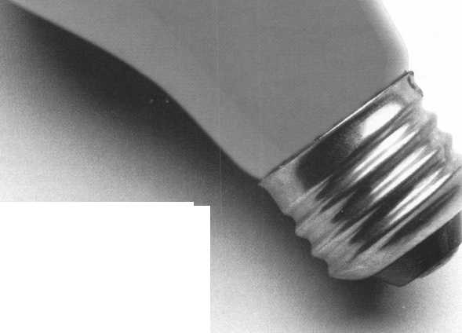

Upcoming

Events



[Dept)

**Cl?** Indicates ALOA ACE Class **0^** Indicates PRP Sitting

199©

FEBR&MIJW

1-5

Lockmasters Class Electronic Access Control Nicholasville, Ky.

(800) 654-0637, ext. 200

6-7

West Coast Lock Collectors Show Arcadia, Calif.

Contact: Bob Heilemann (310) 230-3004 evenings only Vic Jackson

(818) 881-9947 evenings only Douglas Huse (626) 797-1610

9-14

Texas Locksmiths Assoc. Annual Convention and Trade Show Contact: Jim Hetchler (registra­tion) (830) 606-1727 or Pat Titus (booth space)

(210) 649-2166

14

**ff** ALOA PRP SITTING Texas Locksmiths Association San Antonio, Texas Contact: Wanda Robbins (210) 923-4381 (210) 977-8398 fax

20-21

^7 ACE Class Fundamentals of Masterkeying Grand Canyon Chapter of ALOA Phoenix, Ariz.

Contact: John Ilk, CRL (602) 425-9666 (602) 420-2174

21

# ALOA PRP Sitting Rocky Mountain Locksmiths Assoc. Airora, Colo.

Contact: John S. Todd, CRL (303) 730-8525 (303) 795-5114

22-23

Lockmasters Class Advanced Lock Picking Nicholasville, Ky (800) 654-0637, ext. 200

27-28

Lockmasters Class Simplex Certification Nicholasville, Ky (800) 654-0637, ext. 200

27

**CC** ACE Classes Studying for and Passing the PRP Western Mich. Locksmith Assoc. Kalamazoo, Mich.

Contact: Terry L. Bussema, CRL (606) 381-5634 (606) 381-5654 fax

28

**f/** ALOA PRP SITTING Western Michigan Locksmiths Association, Kalamazoo, Mich. Contact: Terry L. Bussema, CRL (616) 381-5634 (616) 381-5654 fax

28

Local Organizations for Continuing Education- South Florida Locksmiths Assoc./ Florida Latin Locksmiths Contact: Jerri (days)

(305)944-0469;

or Wayne (evenings)

(305) 252-8355

MAFtCEKl

9-12

ISC Expo/Las Vegas ’99 Las Vegas, Nev.

Contact:

(203) 840-5602 <http://isc.reedexpo.com>

12-14

IDN Hardware Sales, Inc. Security Conference Cleveland, Ohio Contact: Fred Strasberger, John Kress or Bonnie Weston (800) 521-0955

18-21

**Vr** ACE Classes Sponsor:

MLANJ Annual Convention Somerset, NJ (973) 267-8884 (973) 538-2248 fax [www.mlanj.org](http://www.mlanj.org)

20

**fjf** ALOA PRP Sitting MLANJ Somerset, NJ

Contact: Bill Timmann, CML (973) 267-8884 (973) 538-2248 fax

20-21

MBA Training Manipulation Nicholasville, Ky.

(888) 622-5495

21

Southern Lock Buyers Trade Show St. Petersburg, Fla.

Contact:

(800) 282-2837

28

ALOA PRP Sitting Rosemont, 111.

Clark Security Products Contact: Terri Burges (619) 974-5273 (619) 974-5284 fax

APK1L

n

,# ALOA PRP SITTING Montana Chapter of ALOA Butte, Mont.

Cooney s Locksmith Contact: Walter P. Cooney, CML (406) 782-0125 (406) 782-0125 fax

11

**^** ALOA PRP Sitting Oakland, Calif.

Clark Security Products Contact: Terri Burges (619) 974-5273 (619) 974-5284 fax

12-16

MBA Training

DoD Combination Locks

Nicholasville, Ky.

(888) 622-5495

17-18

MBA Training Professional Safe Drilling Nicholasville, Ky.

(888) 622-5495

20-21

ASTM Meeting on Security Systems and Equipment Seattle, Wash.

Contact: Cynthia Blackwell (610) 832-9737

MM

4-9

SAFETECH ’99 Las Vegas, Nev.

(214) 827-7233

15

MBA Training Expert Lock Picking Nicholasville, Ky.

(888) 622-5495

16

MBA Training Expert Lock Picking Nicholasville, Ky.

(888) 622-5495

JUNE

19

MBA Training Safe Deposit Locks Nicholasville, Ky.

(888) 622-5495

20

MBA Training Time Locks Nicholasville, Ky.

(888) 622-5495

july

25-31

ALOA ’99 Security Expo Cincinnati, Ohio (800) 532-2562

AUGUST

22

ALOA PRP Sitting Baltimore, Md.

Clark Security Products Contact: Terri Burges (619) 974-5273 (619) 974-5284 fax

27-30

MLAs London Convention Contact: Dave Stokes 139 Wood Street Walthamstow, London, El7 3LX 01144 181 520 7450

OCTOBER

2000

APSIS l

6-9

MLANJ 2000 Annual Convention Somerset, NJ (973) 267-8884 (973) 538-2248 fax [www.mlanj.org](http://www.mlanj.org)

MM

5-10

SAFETECH 2000 Birmingham, Ala.

(214) 827-7233

JULY

17-22

ALOA 2000 Las Vegas, Nev.

(214) 827-1701

2001

MARCH

28-April 1

MLANJ 2001 Annual Convention Somerset, NJ (973) 267-8884 (973) 538-2248 **(ax** [www.mlanj.org](http://www.mlanj.org)

JULY

15-21

ALOA 2001 Security Expo Baltimore, Md.

(800) 532-2562

2002

JULY

21-27

ALOA 2002 Security Expo Rosemont, 111.

(800) 532-2562

10

**fk** ALOA PRP Sitting Burbank. Calif Clark Security Products Contact: Terri Burges (619) 974-5273 (619) 974-5284 **(ax**

17

**fj\*** ALOA PRP Sitting Penn/Ohio Locksmith Assoc. Coraopolis, Pa.

Contact: Martha R. Eggler (216) 676-8464 (216) 267-2511 **(ax**

***Keynotes***

February 1999

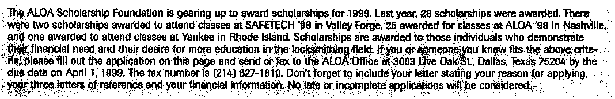

ALOA SCHOLARSHIP FOUNDATION, INC.

ALOA/SAVTA SCHOLARSHIP APPLICATION  
3003 Live Oak Street; Dallas TX 75204; (214) 827-1701

Please print or type

NAME PRP LEVEL ALOA/SAVTA # HOME ADDRESS CITY STATE ZIP

HOME PHONE- DOB // EDUCATIONAL LEVEL **(YEARS)** DEGREE, IF ANY

PRESENT EMPLOYER WORK PHONE- FAX

WORK ADDRESS CITY STATE ZIP POSITION □ FULL TIME □ PART TIME TAKE HOME PAY $

LENGTH OF TIME IN LOCKSMITHING OWNER/SUPERVISOR’S FULL NAME MEMBERSHIP IN TRADE ASSOCIATIONS GUST BY NAME]

MARITAL STATUS SPOUSE’S OCCUPATION SPOUSE’S TAKE HOME PAY $

COMBINED HOUSEHOLD ADJUSTED GROSS INCOME $ NUMBER OF DEPENDENTS

CLASSES DESIRED DATE OF CLASSES //

ORGANIZATION SPONSORING CLASSES: □ ALOA □ SAVTA □ OTHER (PLEASE NAME]

LOCATION

ALOA Scholarships are granted to selected individuals desirous of entering the locksmithing field or to selected individuals already in the locksmithing field who wish to improve their professional skills through education.

Applications for classes being taken locally must be received a minimum of 60 days prior to the date of the class, and will be reviewed as they are submitted. Scholarships for classes at the ALOA or SAVTA convention will be awarded each year at the ALOA Scholarship Foundation meeting preceding the convention and must be received by April 1 each year.

Please attach to this form a letter stating your reason for applying for a scholarship, what you plan to do with the knowledge you obtain and any other information you feel may be helpful to the scholarship board in making its decision. In addition, attach three let­ters of reference from individuals who have personal knowledge of your background and character. The letters should contain their names, addresses and phone numbers. It would be helpful if at least one of these references is an ALOA or SAVTA member. Also, please provide a copy of your most recent tax return.

All scholarship recipients will be required to provide a 3x5 inch photograph of themselves.

APPLICATION CHECK LIST

Only complete applications will be considered for scholarships. An application is considered incomplete unless ALL of the above requested information is received before the deadline: 60 days prior to the date of a class or April 1 for ALOA/SAVTA convention classes. Please send this application after checking off each of the below.

* I have filled in each blank on this form.
* I have written and enclosed a letter explaining my reason for applying.
* I have enclosed three letters of reference.
* I have enclosed a copy of my most recent tax return.
* I am submitting this in time to be received 60 days prior to the date of a class or by April 1 for ALOA/SAVTA convention classes.

CERTIFICATION OF APPLICANT:

I certify that the information contained herein, and all supplemental forms are complete and correct to the best of my knowledge. I further certify that if I am selected as a scholarship recipient I will use the knowledge gained for the improvement, development and advancement of the locksmithing profession.

Signature

Date

/

/

01/99

Keynotes



February 1999



Sanyo

Sanyo Security Video has released a camera that operates under three different conditions regardless of the surrounding lighting. The VCC-4324 automatically switches from color mode during regular lighting conditions to black and white for use in low- light situations to infrared mode under very low-light conditions. The camera was designed for such applications as unmanned security installation in bank ATMs, traffic/parking lot control, warehouses, office buildings and retail establishments.

Sanyo

21605 Plummer Street Chatsworth, Calif. 91311 (818) 998-7322 (818) 701-4182

Sensormatic Electronics Corp.

Sensormatic Electronics Corporation announced the release of C*Cure 750 access control and alarm monitoring system that offers an enhanced user interface, fully integrated video badging capabilities and Windows ’98 support. A toolbar contains icons representing the most common functions it performs. Each icon is also available from the new drop-down menus. The monitoring window has also been enhanced with an icon associated with each cardholder message (reject or admit) that, when selected, causes the image of the cardholder to be displayed.

Sensormatic Electronics Corporation 951 YamatoRoad PO Box 310700 Boca Raton, Fla.

(561)989-7000 (561) 989-7373

Jensen Tools

Available from Jensen is a five-piece insulated nutdriver set. Each is manufactured with IEC900, ASTM-1505-94, VDE and DIN 7437. Each is individually tested to

1. v and certified to 1000 VAC or 1500 VDC. The blades are constructed of black finish chrome-vanadium steel with the insulation molded directly on the blades for permanent bonding. The nutdrivers have 1"

81 ***Keynotes***

deep drawn sockets and large comfortable, impact resistant handles. The set includes 7/32", 1/4", 3/8" and 1/2" sizes.

Jensen Tools 7815 46tb Street Phoenix, Ariz. 85044-5399 (602) 968-6241 (602) 438-1690fax

Trans-Atlantic Company

Now available from Trans-Atlantic Company is a new exterior panic lock trim. It’s an integrated unit with a mortise cylinder locking feature in three models. Knob, lever and with thumb latch. All three models are available with either 1 3/4" wide or 2 1/2" wide rectangular estucheon. It is for use on all types of commercial doors including ANSI prepped steel and wood door, non-ANSI prepped steel and wood doors and trim line aluminum doors. It can be used with most brands of handed and non-handed touch bar and conventional type panic rim exit devices, activated by tail piece. It is available in aluminum, duronodic and bronze finishes.

Trans-Atlantic Company 440 Fairmount Ave.

PO Box 37006 Philadelphia, Pa. 19123

Wells Lamont Industrial

Wells Lamont Industrial, one of the nations leading manufacturers of work gloves and related apparel for a variety of industrial applications, now offers EarGrips ear warmers as an addition to its line of work related products. EarGrips insulate ears from the wind and cold with a double layer of warm polyblend fleece. The ear warmers are ergonom­ically-engineered with a built-in sizing mech­anism to provide a personalized fit. EarGrips are available in black and safety orange.

Wells Lamont 6640 West Touhy Ave.

Niles, III. 60714-4587 (847) 647-8200 (847) 647-6943 fax

Vision Systems, Inc.

Vision Systems released a product designed to meet the security needs of the small to medium sized retail operations. The product, known as InSight is an integrated, monitored alarm and closed circuit television system, which also provides the ability for the owner/manager to obtain video from the protected property remotely using a laptop or desktop computer. Central to InSight is a device known as Bi-Sensor, which combines an infrared sensor, camera and microphone in one unit. The Bi-Sensor design allows for discreet monitoring as it appears to be a standard alarm sensor. Therefore, most people would be unaware that the device is also a high revolution video camera with an extremely sensitive microphone.

Vision Systems, Inc.

35 Pond Park Road Hingham, Mass 02043

Cold Steel

Two new lockback knives are available from Cold Steel, the Vaquero and the Vaquero Grande. Both feature a 3.5 mm thick blade made from the finest AUS 8A stainless steel, a non-slip Zytel handle and a serrated blade edge. The Vaquero Grande blade length is six inches long, measures 13 1/4" when opened, 7 1/4" closed and weighs just 6.2 oz. The Vaquero blade length is 5" long, measures 11 3/8" when opened, 6 3/8" closed and weighs a mere 4.6 oz. A new metal clip allows for an easy and comfortable fit in most pockets. In addition, both knives feature a thumb stud for one-handed opening with either the right or left hand.

Cold Steel

2128-D Knoll Drive Ventura Calif. 93003 (800) 255-4716

Jet Hardware Manufacturing

The DA31-N-PHT Transponder Blanks for the Nissan Maxima and Infinity auto­mobiles are now available for locksmiths to sell their customers. Required is the ETD-1. It has the foremost technology to copy and duplicate on Jet s or any manufacturers including OEM key blanks. The ETD-1 will

February 1999

handle Nissan’s products at this date other than the dealers original equipment.

Jet Hardware Manufacturing Corporation 800 Hinsdale St.

Brooklyn, NY 11207 (718) 257-9600 (718) 257-0973 fax

L&S Security Products

L&S manufactures a line of inter­changeable key switches and push-button controls. Key switches provide restricted control of electrically operated door systems, alarms, equipment, lights, etc. This limits actuation to authorized key carrying personnel. Features include a patented unique one-piece construction manufactured from a die cast heavy duty aluminum. Plates are available for single-gang boxes or in a narrow size for hollow metal frame mounting. Standard finishes include brushed aluminum, silver (US28) and bronze (US 40) powder coating. Units will accept any standard (1 1/4") mortise cylinder (not included) allowing one to key into existing systems. Switches are individually mounted, so that the unit can be changed or upgraded and dual switch capability is standard on all plates. Units come with a mortise cylinder locking nut ring and security screws. A variety of switch configurations rated six amps **@125** VAC are available (SPST NO/NC/On-Off, SPDT On-Off/Maintained, SPST NO/NC solid red push buttons). Exit controls prominently engrave handicap or exit logos on the plates. LEDs are optional. Outdoor units are provided with four holes and a weather proof gasket with or without the single gang box included.

L&S Security Products 13418 Halldale Ave.

PO Box 1337 Gardena, Calif 90249 (310) 329-2268 (310) 532-4988fax

Security Lock Distributors

LCNs electrically powered 4622 series automatic door operator is now inventoried, in depth, at all Security Lock warehouse

centers. The UL and ULC listed 4622 permits doors to open slowly, providing access for the elderly, frail or disabled. It eliminates the need for guardrails or safety mats and meets ADA requirements. Interior doors to 4'6" are accommodated, as are exterior doors to 3'6". The operator is non- handed and available in different finishes and offers many systems options.

Security Lock Distributors (800) 847-5625

[SECLOCK@IX.NETCOM.COM](mailto:SECLOCK@IX.NETCOM.COM)

wtvwlsechck.com

Videx

Available from Videx is TouchAlert. TocuhAlert is an access monitoring device that records any authorized entry with ID number, date and time. Also available is TouchAccess, which provides all of the same capabilities plus additional enhancements. These include an alert that’s sounded to central or local location, or both, a directly wired power supply and output to a solenoid to activate a locking device.

Videx

1105 NE Circle Boulevard Corvallis, Ore. 97330 (541) 758-0521 (541) 752-5285 [sales@videx.com](mailto:sales@videx.com) tvww.videx.com

Steck Manufacturing Company

Steck presents the BigEasy Tool. It unlocks cars and light trucks without the danger of airbag activation or disconnected linkages because none of the tools enter the door cavity. The upper doorframes on cars will easily spring out far enough to give the BigEasy access to the interior of the car. The tip of the BigEasy is then used to actuate the electric or manual lock buttons/slides, or the interior door handle.

Steck Manufacturing Company 1115 S. Broadway Dayton, Ohio 45408 (937) 222-0062 or (800) 2278325 (937) 222-6666

Security

Marketplace

Sargent and Greenleaf

Sargent and Greenleaf s new Time Commander II when used with S&G’s Comptronic Electronic Safe Locks, provides time lock capability to secure safes and protect against robbery and internal theft. A programmable, electronic time lock module, the TCII can be used for high cash transaction business operations. By controlling electronic safe locks to open only during pre-set, specified periods, the TC II is used in protecting safes, cash and employees in retail stores where stores are open 24 hours a day. Using touch buttons, users can schedule multiple open/close periods in any 24-hour time frame and if desired, copy the schedule quickly to other days. This assures access top cash only during limits, pre­determined and approved times.

Sargent and Greenleaf PO Box 930

Nicholasville, Ky 40340-0930

NAPCO Security Group

NAPCO Security Group will produce field changeable brown housings for use with the standard GEMTRANS@ RF Window/Door Transmitter. It’s designed to blend in with wood grain window and doorframes, the brown housings are to be used with the standard GEN-TRANS2 electronics. The dealer can switch the electronics from supplied white housings to the new brown housing as site decor dictates. The brown housings will be sold in packages of 25.

NAPCO Security Group (800) 645-9445

February 1999

Keynotes H

***The following applicants are scheduled for clearance as members of ALOA. The names are published for member review and comment prior to March 1, 1999, to ensure applicants meet standards of ALOA’s Code of Ethics. Protests, if any, should be addressed to the Membership Department and***



***must be signed. Active Membership applicants (A) have worked in the indus-  
try two or more years. Allied Membership (AL) applicants are not  
locksmiths, but work in a security-related field. Apprentice Membership (AP)  
applicants have worked in the industry less than two years. A***

USA

ALABAMA

Auburn

028653, Thomas E Cobb, A SPONSOR: John Brooks

CALIFORNIA

Los Angeles

028693, David M Sullivan, A SPONSOR: Robert Duman

Santa Clara

028706, Tom M Walker, AP

DISTRICT OF COLUMBIA Washington

028640, Vonfranklin Marshall, A SPONSOR: David Maye 028703, Tuan A Trang, AP

DELAWARE

Newark

028651, James T Fiore, A

FLORIDA

Miami

028650, Richard W Fetter, A SPONSOR: William Banks

INDIANA

Elkhart

028691, Bud McGlinsey, A SPONSOR: Melanie Sherer 028690, Jack Sherer, A SPONSOR: Melanie Sherer

Indianapolis

028701, James F Buckner, A 028702, Duke A Drummond, A 028700, Shirley A Graham, A

KENTUCKY

Louisville

028681, James M Davidson, A SPONSOR: William Jenkins

MARYLAND

Baltimore

028698, Peter J Konizeski, A

Beltsville

028638, James E Rednowers, A SPONSOR: Robert Smith

Davidsonville

028639, Lance A Edwards, A SPONSOR: Andre Lowery

Silver Springs

028697, Anthony A Boniface, A SPONSOR: Brian Sullivan 028696, Edward S Jones, A SPONSOR: Brian Sullivan

MAINE

Springvale

028687, Carol A Atwell, A

MICHIGAN

Auburn Hills

028646, Charles A Garvin, AP SPONSOR: Patrick Sullivan

Decatur

028641, Doug A Rosenbach, A SPONSOR: Mark Rosenbach

Holland

028704, Trent D Van, A SPONSOR: M Van De Brake

MINNESOTA

Prior Lake

028689, Richard A Pedinski, A SPONSOR: Richard Sievers

MISSOURI

Jefferson City

028685, David D Spires, AP SPONSOR: P Hunton

St Louis

028682, Victor G Quante, AP SPONSOR: Eric Krause

MISSISSIPPI

Biloxi

028648, Allen J Starnaud, A SPONSOR: Daniel Landry

Hattiesburg

028694, Debra A Bankston, AP SPONSOR: Richard Harper

NEW MEXICO Las Cruces

028649, Andy A Gonzales, A SPONSOR: Donald Brazil

NEW YORK

St James

028677, William DeBetta, A SPONSOR: Richard Grudens



Keynotes

February 1999

OHIO

Cincinnati

028675, Jason G Smith, A SPONSOR: Michael Rumage 028688, Joann M Taylor, AP SPONSOR: Lawrence Smith

East Cleveland

028644, Jimmie W Jones-Bey, AP SPONSOR: Maurice Horne Leavittsburg 028695, Loral Boyd, AP SPONSOR: Maurice Horne Shaker Heights 028645, Morris Collins, AP SPONSOR: Maurice Horne

RHODE ISLAND West Warwick

028633, August J Gomes, A

TENNESSEE

Sparta

028652, William O Byberg, AP SPONSOR: Jim Jeffries

TEXAS

Bryan

028705, John E Hines, A SPONSOR: Kevin Griffin

Garland

028692, Kevin P Dean, A

VIRGINIA

Chesapeake

028699, Robert A Hughes, A

Reston

028684, Roger E Thomas, AL

Salem

028686, David W Keyser, A SPONSOR: Clyde Roberson

Spotsylvania

028683, Kerlin C McManious, A SPONSOR: William Johnson

WASHINGTON

Spokane

028680, Allen C Albano, A SPONSOR: Johnny Coffey

Tacoma

028647, Matthew A Herbold, A SPONSOR: Charles Beavers

WISCONSIN

Madison

028678, Sean M Friedl, A SPONSOR: Tom Ripp

Manitowoc

028676, Thomas E DeWolf, A SPONSOR: Steven Spiwak

HONG KONG

Chai Wan

028679, Chan Chau, A SPONSOR: Kwok-kei Leung

IRELAND

Raheny, Dublin 5

028642, Alan B Houlihan, AL

JAPAN

Hiroshima City

028636, Nobuya Handa, A SPONSOR: Hatsuo Nakai

Kasaoka,Okayama

028643, Hiroshi Omura, A SPONSOR: Koichi Fujii

Legislative Updates

by Tim McMullen

MISSISSIPPI S2649

AUTHOR: White

INTRODUCED: 01/15/1999

SUMMARY: Provides for lthe licensure and regulation of

burglar or intrusion alarm system installers;; defiens certain terms used in the act; creates the Electronic Security board of Licensure; definition of “burglar alarm” ties it to a monitoring service that calls someone to respond.

STATUS: 01/15/1999 INTRODUCED.

01/15/1999 To SENATE Committee on BUSINESS AND FINACIAL INSTITUTIONS.

NEW YORK A515

AUTHOR: Kaufman, et al

INTRODUCED: 01/06/1999

SUMMARY: Provides that class A multiple dwellings have eight

or more apartments erected or converted prior to 1968, must have automatic self-closing and self­locking doors at every entrance from the street, roof, passageway, courtyard, cellar or other entrance; excludes main entrance halls and lobbies if equipped with automatic self-locking doors.

STATUS: 01/06/1999 INTRODUCED.

01/06/1999 To ASSEMBLY Committee on HOUSING.

NEW YORK A 718

AUTHOR: Hill, et al

INTRODUCED: 01/06/1999

SUMMARY: Permits a state income tax deduction for home

security devices, including but not limited to exterior lighting, installed by the owner occupant of a one, two or three family home for an amount not to exceed $500.

STATUS: 01/06/1999 INTRODUCED.

LEGISLATIVE ACTION NETWORK

I am interested in: CD Working on Legislative Issues CD Fundraising CD Gathering/Giving Information

Name:

ALOA member number:

Company:

Company Address:

City, State ZIP:

Home Address:

City, State ZIP:

Telephone:

Fax:

E-mail:

ISI Mail this completed form to:

LEGISLATIVE ACTION NETWORK, Associated Locksmiths of America, 3003 Live Oak Street, Dallas, TX 75204.

NOTE: The following legislation is new. Please refer to January Keynotes for legislation introduced in 1998 and carried over for the 1999 legislative session (there has hem no movemmt on any carry-over legislation)

ARIZONA H 2493

AUTHOR:  
INTRODUCED:  
SUMMARY:

STATUS:

CONNECTICUT S 112

Gerard, et al 01/12/1999

Relates to locksmiths; relates to work orders; relates to information retention.

01/12/1999 INTRODUCED.

AUTHOR:

INTRODUCED:

SUMMARY:

STATUS:

INDIANA S 53

AUTHOR:

INTRODUCED:

SUMMARY:

STATUS:

Gaffey

01/11/1999

Requires the licensing of locksmiths.

01/11/1999 INTRODUCED.

01/11/1999 To JOINT Committee on GENERAL LAW.

Meeks

01/06/1999

Requires a person who operates a business that installs, repairs or services an alarm system to be licensed; establishes an alarm system board; establishes licensure and registration require­ments for the regulation of alarm system contrac­tors and their employees; requires employees of an alarm system contractor to be registered and have identification cards; staggers the terms of the initial appointments to the board. 01/06/1999 INTRODUCED.

01/06/1999 To SENATE Committee on PUBLIC POLICY.

February 1999

Keynotes I

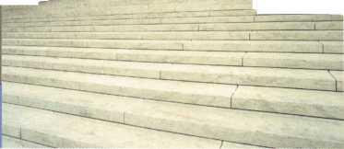

. .All the Sentry safes in the line are UL tested for one- or two-hour fire protection, ensuring that their contents will remain safe and unharmed, even at temperatures up to 1700°F."

February 1999

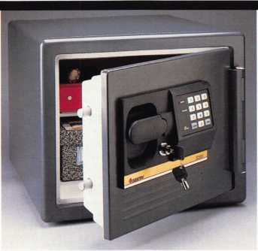

• Consumer Feedback Ignites Sentry’s Fire Safe

Consumer reaction was the inspiration behind Sentry Group’s new steel hire Safe line. Fire resistant, water proof and designed to withstand the threat of thieves, the Fire Safe provides different locking options as well as adjustable or removable organization features.

“The information from consumers was collected from a quantitative research study,” says Joe Oelgoetz, Marketing Director at Sentry. “Basically, we went to six different markets across the country and surveyed about

1. individuals. They took a look at a safe several different ways with regards to what kind of features they would want and how much they would be willing to pay for these features.”

The product is available in a variety of models (the Personal, Home and Advanced Home/Office) that come with either manual combinations or electronic locking mechanisms. It also offers different locking options as well as removable organization features that adjust to meet the user’s specific storage needs.

The most requested options from the consumers examined were fire and water protection. Oelgoetz says that the consumers studied weren’t necessarily safe owners, but rather people who would consider buying a safe in the near future.

Among the features that Oelgoetz feels are most unique to the Fire Safe is its ability

**core**

to custom organize with drawers, shelves or trays with a new rail system.

“The actual internal feature of the safe being a molded interior, so you can customize it to your exact needs whereas before the Sentry safe "coulcTonly centralize its contents. We found through our research that organization is very important to the end user.” he says.

“I think some of the stuff we’ve put into this safe are fairly revolutionary,” he continues. “I can’t say that there’s a safe in the market that delivers on water resistance. Also, all of our safes now pass the UL 30 foot fire impact test and we offer a “fire protection” guarantee, which allows us to reimburse the owner a certain amount of money if the unit fails in a fire.”

Oelgoetz says that a version will soon be available for locksmiths with even more additional features than the mass market line.

**execs**

Michael P. Petersen has joined Detex Corporation as International Sales Manager. ... Streamlight, Inc. promoted Mike Albert to Director of Law Enforcement and Sporting Goods Sales and Jeff Orr to Assistant Director of Law Enforcement and Sporting Goods Sales. The company has also named Ed Gruber to National Accounts Director. ... NAPCO Security Group has named Jorge Hevia as Corporate Vice President of Sales and Marketing.

Keynotes

• regions

The South Carolina Locksmith Association recently announced its new officers and board members at its quarterly meeting in Columbia, SC.

They are as follows:

OFFICERS:

Lee Griggs - President

Tonia Boling - First Vice President

Mark Mullinax - Second Vice President

Sturgis Gibson - Treasurer

Kevin Wilson - Assistant Treasurer

Ron Styles - Sergeant at Arms

Faye Leslie - Assistant Sergeant at Arms

BOARD MEMBERS:

Mark Evans, Rhoda McClain, Phil Ashley, Phil Lumadue, William Allgood and Tom June.

The Cowboy Locksmith Wyoming Locksmiths Association will hold its spring meeting April 30 through May 2.

• on the web

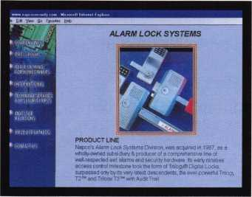

Alarm Lock is on the web at <http://www>. alarmlock.com. The new site is designed to be very user friendly and loaded with product information including the facts on on Excalibur Access Control Systems. It also allows customers to connect with the customer service department and interna­tional sales representatives.

• fore!

Among the names you’ll probably hear at this year’s Senior Tour Championship are Rodriguez, Trevenio and Ingersoll-Rand.

That’s right, Ingersoll-Rand. The industrial hardware and components manu­facturer has agreed to a four year title spon­sorship of this season-ending golf event. Now named the Ingersoll-Rand Senior Tour Championship, it will feature 31 top stars and will be televised nationally on ESPN from Myrtle Beach, SC November 4—7.

...The Northern Indiana Chapter of ALOA will hold its next general meeting February 23. Its Hardware Sales Trade Show will be held March 12-13 in Cleveland, Ohio. ...The next Central and Southern Colorado Locksmith Association meeting will be held on February 19 at 7 pm at St. Joseph Church in Colorado Springs. It will feature a presentation on the Dorma ED600. The following day (Feb. 20) from 8 am to 3 pm, the association will sponsor a Rolland Safe presentation at Acoma Locksmith Service. . ..The Oklahoma Master Locksmith Association s next meeting will be February 19 at 7 pm at the Holiday Inn in Broken Arrow. The associa­tion’s trade show will be the next day from 9 am to 5 pm with a special lunch at noon and the membership meeting at 7 pm. On February 21, OMLA will have a class given by a distributor to be announced.

* going electronic

Mazuik & Co., wholesale locksmith distributors has added a new electronic security products division. Aside from their usual selection of safes, door hardware and locksmith supplies, dealers can purchase burglar and fire alarm products, closed circuit television and access control equipment.

* don’t forget!

We know that all of you have a lot on your minds these days. But one thing you shouldn’t forget about is to vote for Keynotes’ “Author of the Year.” As mentioned last issue, this year, it’s “Reader’s Choice,” so start thinking about the articles you’ve read since April ’98 up until March ’99. The voting ballot will be in the March issue and reminders will be posted in further issues.

* Stan Fuher Scholarship Fund

Last month, we were sad to announce the passing of industry great Stan Fuher.

In his honor, the Stan Fuher Scholarship Fund is in the process of being developed to help Safe Techs in the pursuit of education. Presently, donations are being accepted for this fund and interested parties or those with additional questions can contact Dan Graffeo at (888) 798-8464

* we’ve got a winner!

Some of you may remember that ALOA was giving away an ITL950 Key Machine for a lucky member whose dues were paid by the first of the year. Well, we have a winner! Congratulations to Steven D. Resel of McDonough, Ga. whose dues were promptly paid by January 1, 1999-

Also, a special thanks goes out to Intralock Tools, Ltd. who donated the ITL950!

* notice to all ALOA members

At the recent ALOA Board of Directors meeting in Dallas, Texas, the Board added a new clause to the Code of Ethics, which states,"All ALOA members must abide by applicable licensing and business regula­tions." This means that if a member's state, county or municipality has a registration or licensing requirement, that member must be in full compliance with the law or regulation, or be in violation of the Code of Ethics. The ALOA Board of Directors determined this addition was necessary in order to maintain the integrity of ALOA Membership.

* correction

In the November issue of Keynotes, former ALOA president Evelyn Wersonick was credited with an award at the Greater Philadelphia Locksmith Association’s 49th Annual Banquet. In truth, she was in attendance and accepting an award on behalf of Women in Locksmithing.



• obituaries

ALOA bids farewell to one its valued members, Mr. Stephen Kamzic. Known to some as “Steve” the Locksmith, Kamzic passed away at the age of 63.

Otto Strehlau #9192 recently passed on. The 70 year-old Strehlau was the retired owner of Strehlau Locksmithing and Carpentry.

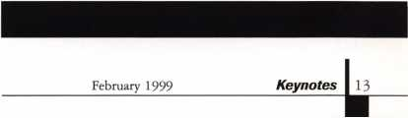

What ALOA Board Positions Are Open  
and Where Am I Qualified to Run?

There are currently six regional director positions open for election in addition to the position of President. ALOA members now elect the directors from their own regions. Only ALOA members from a region are elegible to run for the open positions) in that region. And only members from the nominee s region will be receiving a ballot to vote for that candidate. Members from any region are eligible to run for the President s position. You must have been an ALOA member for at least three years to run.

The following vacancies will exist for the election to be held before the ALOA ‘99 Convention.

Southeast two directors

North Central two directors

Southwest two directors

President

If you have any questions, please contact Charles Gibson at (800) 532-2562 or email [charlie@aloa.ioffice.com](mailto:charlie@aloa.ioffice.com) Below you will find the required nomination petition and on the opposite page, there is the actual nomination form.



Associated Locksmiths of America, Inc.

Board of Directors Nomination Petition

Please print legibly or type. A total of 25 signatures are required.

This form can be reproduced if needed.

I, the undersigned, request that

(name of nominee and member number)

be placed on

the ballot forfor the election to be held at the

(position for which individual is being nominated)

special meeting of ALOA members to be held in 1999 or any adjournment thereof. I am eligible to vote in theregion.

|  |  |  |
| --- | --- | --- |
| PRINTED NAME | MEMBER # | SIGNATURE |
| PRINTED NAME | MEMBER # | SIGNATURE |
| PRINTED NAME | MEMBER # | SIGNATURE |
| PRINTED NAME | MEMBER # | SIGNATURE |
| PRINTED NAME | MEMBER # | SIGNATURE |
| PRINTED NAME | MEMBER # | SIGNATURE |
| PRINTED NAME | MEMBER # | SIGNATURE |
| PRINTED NAME | MEMBER # | SIGNATURE |
| PRINTED NAME | MEMBER # | SIGNATURE |
| PRINTED NAME | MEMBER # | SIGNATURE |
| PRINTED NAME | MEMBER # | SIGNATURE |
| PRINTED NAME | MEMBER # | SIGNATURE |
| PRINTED NAME | MEMBER # | SIGNATURE |

|  |  |  |
| --- | --- | --- |
| PRINTED NAME | MEMBER # | SIGNATURE |
| PRINTED NAME | MEMBER # | SIGNATURE |
| PRINTED NAME | MEMBER # | SIGNATURE |
| PRINTED NAME | MEMBER # | SIGNATURE |
| PRINTED NAME | MEMBER # | SIGNATURE |
| PRINTED NAME | MEMBER # | SIGNATURE |
| PRINTED NAME | MEMBER # | SIGNATURE |
| PRINTED NAME | MEMBER # | SIGNATURE |
| PRINTED NAME | MEMBER # | SIGNATURE |
| PRINTED NAME | MEMBER # | SIGNATURE |
| PRINTED NAME | MEMBER # | SIGNATURE |
| PRINTED NAME | MEMBER # | SIGNATURE |

iiL Keynotes

February 1999

YOUR COMMITMENT TO ALOA BOARD SERVICE

(Please read carefully and sign where indicated.)

The responsibilities of an ALOA board member include contributing a moderate amount of personal time, and a significant degree of professional guidance and expertise to the organization.

You will be expected to come to board meetings, and the annual membership meeting, prepared to sensibly discuss matters of great importance to your profession and prepared to set policy as part of a governing body. Your course of action during your tenure on the ALOA board should be guided by fairminded, constructive and achievable goals pertaining to mat­ters of consequence for ALOA and for the industry. Your contributions are expected to bene­fit ALOA as a whole, taking individual member rights and concerns into account, but free of the taint of partisan politics or personal gain.

On a practical note: ALOA board members are expected to behave and dress professionally at all times, especially when actively representing the association. ALOA board members are required to participate in two board meetings per year, of three to four days in length, one each fall and spring. Board members are also asked to attend the annual convention and are required to attend the annual membership meeting. Board members may also be asked, on a voluntary basis, to represent ALOA at related local, state or regional functions, including serving in the ALOA Booth and otherwise promoting ALOA. When travel is required for a board member, expenses covered by ALOA include lodging, travel and a rea­sonable **per diem.** The Board has stipulated that assigned travel will be reimbursed at the lesser of the 30-day advance tourist class airfare in effect at the time of travel or the current per-mile rate for travel by personal automobile. Spouse expenses, including extra room

charges, etc., are the individual’s responsibility.

* * *

I have read and understand the above responsibilities of an ALOA board member, and agree to commit my time and energies as needed. I certify all of the information contained on this form and supporting documentation to be true and complete.

I can be contacted with questions at:

Address Phone #

Signed: Date:

Please attach a recent photograph of yourself and retain a copy of this profile for your own files. This profile and all supporting documentation should be submitted no later than April 1,1999.

Mail to: Nominee Profile

Secretary of the Board of Directors  
Associated Locksmiths of America  
3003 Live Oak Street  
Dallas, TX 75204-8186

REV. 7/98

February 1999

***Keynotes***

Perhaps the biggest obstacle most locksmiths have to overcome  
when getting into electronics is a sense of “technophobia.” Of course,  
certain fears of circuitry, electricity or programmable lock/security  
hardware are to be expected from even the bravest of souls considering  
the industry’s ever-changing tide of technology.

“That’s the biggest thing to get over when getting into any kind of  
specialty,” says Ed Hite, electronic lock expert and head of the Electric  
Locksmith Company in Lee’s Summit, Mo. “It doesn’t matter if its  
electric locking, safe work, master keying, anything. People get afraid of  
this stuff. I remember one of my first jobs as a locksmith was rekeying a  
three story building and the next day, nobody could get in their offices.  
But I learned from the experience. Things like this can be terrifying  
when starting a new job.”

By Mike Emery

**The electric**

**IPGKSMiTri'S  
EP HiTE**

**SOUNDS OFF ON**

**electronic security**



Hite has been a locksmith for over 15 years and has been mnning the Electric Locksmith for nine years. His company’s focus is primarily on the electrical locking portion of access control (electric locking, egress and egress codes) although it does specialize in a few other areas (covert surveillance, select models of CCTV). He adds that all of his advertising comes from word of mouth and even their number is unlisted in the Yellow Pages.

Most of his clientele are electronic contractors and alarm companies as well as fairly large commercial accounts. Hite says, that the Electric Locksmith also has a few locksmiths as customers. Many of whom require some advice or “pinch hitting” on various projects. For locksmiths starting to learn the ropes of electronic locksmithing, he offers a reminder that manufacturers often take into consideration to make the installation information readily available and simple to understand.

“It’s to the manufacturer’s benefit to make everything easy for the locksmith to work on a product or put one in,” he says. “They’re usually there with product support or with someone in the field with very detailed directions. It’s real difficult to mess up basic electric strikes, mag locks and basic one-door digital systems. It happens, but manufacturers’ instructions are for the most part, very specific and their customer support is very strong.”

Hite got started in locksmithing at the age of 30. He originally started out working for a restaurant chain, then got involved in main­taining one of its store’s security. After leaving the restaurant industry, he pursued two different careers in locksmithing and real estate. Ironically, he was able to generate leads for locksmithing customers through his real estate contacts. With that, his career in security was beginning to take shape.

When asked about how he got involved in electronics, Hite, 47, has to think a moment and even then, can’t exactly recall his orientation into the field. He says that as a kid, electronics wasn’t his forte but rather biology, which is what he always thought he would end up doing.

“I think I mainly chose to go into electronics because I was dealing in a specific area and I could work at my own pace,” he says. “And when I was done with a job, I could look at it and there was nobody else that influenced whether it was good or bad. Either it was good or it was my fault.”

His philosophy on the field is “not to be a jack of all trades.” Hite maintains that although most locksmiths are encouraged to know a little about everything, there’s no way to know it all. On the flip side of that belief, he does advise freshmen electronic locksmiths not to immediately specialize in one area. He says that depending on where your business is located, it’s difficult to determine which specialty field to practice. So try a little of everything until you narrow it down.

“When I first started in the business, I tried to specialize in electronic locking,” he says. “I found myself doing a lot of cabinet lock rekeying because that was the strongest thing in the area that I was in. That was a few cities ago, and I would have hated to make a living at that time on electronic locking, because I think I sold only two strikes a month.”



Once a locksmith does have his market figured out, then he/she begin exploring the prospects of specialized work. “I found that in locksmithing, there were people that were good in safework and there were people that were good in rekeying deadbolts and home security, and there were some people that hated residential work,” he says.

“We were all pushed to be separate ‘jacks of all trades.’ I kind of disagree with that. Unless you’re like ‘country doctor’ who has to know a little about everything because there’s no one else around, when you’re in the big city and dealing with electronic security, there’s no way you can know it all. You can know a little bit about a lot of systems or you can know a lot about a couple of systems.”

There’s a lot to take into consideration when entering the seemingly complex world of electronics and as mentioned earlier, it may seem utterly frightening. Hite, however, says to stay cool if this is something you may or may not be interested in. In end, all one needs is a little time, patience, research and reassurance to tackle this specialized area.

“Education is important,” he stresses. “But the most important thing to do when starting a specialty is to find a basic class and just jump in, holding someone’s hand. After my first two or three electric strike installations, I wasn’t an expert but I certainly wasn’t afraid anymore.”

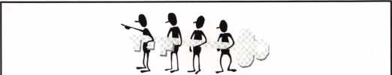

AALANJ 1999  
Annual Convention

March 18th thru March 21stSomerset, New Jersey

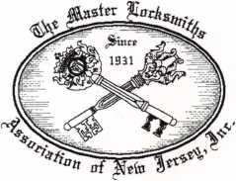

For More Information:

PO Box 2441

Morristown, NJ 07962-2441  
Phone 973-267-8884  
Fax 973-538-2248

Or visit our web site at  
[www.MLANJ.org](http://www.MLANJ.org)

February 1999

Keynotes l_

Oa/imeil

to- the 9atfieAc4

*)3y, WliJie, £m£Ajy,*

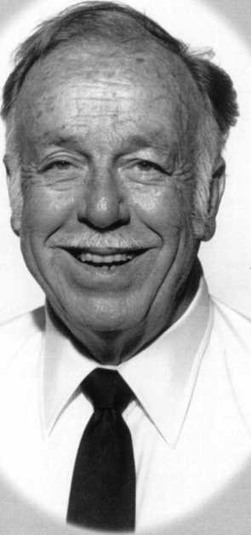

Harry Miller was a legend in both the safe and lock industries. Sadly enough, Harry left us in December at age 86, but those who either knew him or knew of him will never forget his contributions to the security world as an educator and an innovator.

The son of a safeman, Harry’s earliest experiences with safes began at the age of 12. His father was employed at Diebold Safe & Lock in Canton, Ohio and young Harry would accompany him on work-related road trips. By 16, he was already supervising his first safe installation.

In a 1991 interview with Lockmasters, Harry remembered that first job. “My first job in complete charge of erecting a vault was for a newly constructed bank in Clayton, NY,” he said. “I was 16. It was the first time I had charge of the complete installation, the hiring of the people and arranging the carting and hauling. It seemed a natural thing to me. I had no trouble, at that age, handling the job. I felt very comfortable erecting those vault doors and those were beautiful doors. They were not just fireproof doors, they were doors that probably weighed 16-tons or so. Safe deposit boxes lined the walls. I remember those well, and some other very nice vaults I worked on when I was 16 and 17.”

Years later, in 1942, he would take on a routine job that would forever change his life as a locksmith and a safetech. It was to open an old chest filled with jewelry. The lock that secured the chest and its contents was ornate and cleverly constructed. While working on it, he admired its craftsmanship and technical sophistication. After toying with it, he finally got it open, being careful not to damage it.

Not wanting to call Harry back to open the same box, the grateful owner let him have the old lock as part of his payment. Intrigued, Harry began researching it and gathering information about its origin. This began similar investigations on other locks. Before long, his research was transformed into a project of cataloging various locks and devices.

This collection of hardware and informa­tion wasn’t necessarily out of fun. Harry wanted to investigate the workings of an assortment of locks because he was interested in developing his own lock.

“A lot of people were thinking that the lock collection was just a lot of pretty locks,” he said in 1991. “Well, that was not my purpose in starting it. If I was to develop a good lock and have it available for the improvement of security for our government,

I had to study everything being used and find their weaknesses. My collection is based entirely on what makes the lock function and what the design is.”

During WWII, Miller was in demand worldwide as a lock and safe specialist. He later travelled extensively, to open various security deposit boxes and safes for various parties. Among his travels was a journey to China where he opened a gold bullion chest for General Chiang Kaishek and a trip to Cuba where he opened several safes (confis­cated from rebel Fidel Castro) for then- dictator Fulgencio Batista.

Other jobs included opening a presiden­tial safe (during Franklin D. Roosevelt’s term) after the only person who knew its combination was assassinated in South America. He was also frequently employed by the U.S. military during the Korean War to open captured safes.

One night, after working on a combina­tion lock in his workshop, he came up with an idea that would “manipulate” it into opening. After a good night’s sleep, he pursued it the next morning and sure enough, his theory was well-founded.

His concept of “manipulation” (opening a combination through sight, sound and touch without knowledge of the combination) was

February 1999

Keynotes

merely the start of his accomplishments. Soon thereafter, he began to tinker with the concept of an anti-manipulation measure for his proposed new combination lock.

After securing a patent, he took his newly created lock to Sargent and Greenleaf (then based in New York), who manufactured it and repaid Harry with S&G stock. Before long, his efforts had paid off and Harry owned controlling interest in the company and eventually became its president.

During the time he had worked on his patented lock, his collection of other locks had grown immensely. With that, he relocated his lock display into the S&G offices for everyone’s viewing pleasure, and still practiced the art of manipulation.

After realizing that the information he possessed could benefit others in the field, he promoted the idea of teaching classes in manipulation. At first, he collaborated with S&G research director, James “Jim” Taylor, but soon the two found themselves overwhelmed by the intense demand for this course. Next, Leonard Singer (co­founder of Locksmith Ledger and the Locksmithing Institute) was consulted in an attempt to publish a manipulation manual for in-home use.

The result was a popular correspon­dence course that spawned the series of classes, now known as Lockmasters. Inci­dentally, Harry’s father (aka “Miller the Safe Man”) was the founder of Safemasters.

In 1981, Harry Miller was the brain behind three extensive operations; Sargent and Greenleaf, Lockmasters and Safemas­ters. He retired later that year, but remained busy, running his original company, the Harry C. Miller Company. There, he worked on locks, continued his research and served as a resource for obsolete parts and locks.

In the meantime, his son Clay, purchased Lockmasters to keep it in the family and eventually began the process of conducting live classes in different cities.

Harry’s recent departure has left many

saddened yet grateful that he was able to accomplish so much during his lifetime. His feats in the industry have yet to be paralleled and his influence continues to inspire many young locksmiths and lock inventors.

“In my lifetime, I’ve seen locksmiths say if they retain their knowledge and not let it out, they’re going to be ahead of everybody else,” he once said. “I’ve been wanting to share all my life and I feel that by sharing with each other in our industry, all can benefit. This country is big enough for all. We really should try to share those things that help one another. This is basically what I want to do. There are so many things that have yet to be done for the locksmith and of course, I feel that my best friends are locksmiths.”

ALOA sends its condolences to Harry’s family and friends and hopes that the vision he shared with an industry throughout the 20th century will carry over into the millennium and beyond.

%

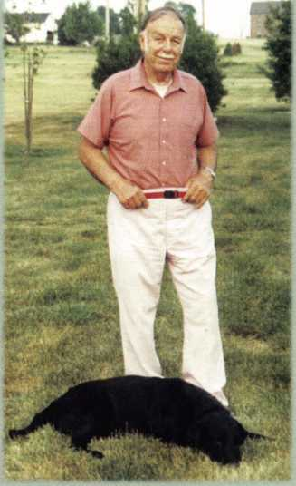

*“9* ***siemem&eA walling with him and tooling at tuA, collection*** o$ ***timelodd, at taAgent and*** *9****'ieentea^. Ue would dtaAt tailing, and would tell you the hidtoAy each lad, alt oft the di^eAent changed, that had occuAAed thwugh the yeaAA., why, they, occuAAed, and do- much moAe.”***

* ***Ronald Deitch, tod coltectoA,***

***“Ue wad, a people tuilden. UaAAgwould put domeonein 'leApondittepoAitiond.andgwe themallthe duppoAttheycould hopejjoA,. UealwagA. encouAaged otheAA. to- teaAn aA. muchad, poAAitle.”***

* ***RaAlaAa CAagcAx^t, tPecAetaAy and AdAociate AdAiAtant at the UaAAg, C. YYlilleA, Company.***

***“Ue’d, a man who- made a di^eAence. Ue changed ouA, induitAy with hid. technical dlilld. and tod development. Ue aldo- went out o$ hid, way to. tepdend the people o$ ouA. induAtAy and help them gAow ad. well cud, paAticipate in education. Ue wad, a peMonal piend to-da many people.”***

* ***Clayton fllitteA, lodmadteAA.***

February' 1999 Keynotes | 19

By Paul F.  
Chandler CRL

(onvenience versus security. Accessi-

bility versus control. Hospitality versus  
hostility. To lock or not to lock?

The advent of electronic locking systems

has meant that there are more  
options available today. In the  
past, opening a retail store for  
business meant unlocking the  
front door so anyone and  
everyone could walk in. Today,  
with increasing fear of armed  
robbery, many retailers use an  
electric lock and screen their  
customers before allowing them  
access. Office buildings, multi-  
family dwellings and other  
facilities also want to limit  
visitor access. Occupants can be  
given an electronic “key” or  
“credential” (a code or card,  
perhaps) but customers, clients,  
trades people and vendors need  
to be identified and admitted.

A doorman or security guard is  
one solution but an expensive  
one. Telephone entry systems  
may be the answer.

All access control systems

consist of an electric locking device and a  
controller that turns the lock on and off.  
Telephone entry systems add a communica-  
tion system which allows a person without  
regular access authority to request entry from  
someone inside the protected space. The  
same objective can be accomplished with a  
dedicated intercom or videophone system,  
and these might be acceptable choices where  
only one or two occupants need to be  
reached. The beauty of using the telephone  
system is that hundreds, even thousands of  
occupants can be reached, anywhere they  
have access to a phone. And the best part is,  
you don’t have to run wires to all of those  
places; “Ma Bell” has already done that for  
you. Several manufacturers of telephone  
entry systems exist. For the sake of this  
article I will refer to products from Select  
Engineered Systems. SES offers two distinct

**Telephone entry systems offer the locksmith excellent opportunities to provide security and convenience for their customers.**

product types : those

using a dedicated phone line and “no

phone bill” systems.

“No phone bill” means that the

product, called “Select Gate', is  
connected to an existing phone  
line, just like you’d add an  
extension phone. A “push-to-  
call” button on the face of the  
unit causes the other extension  
phones on the same line to  
ring. Picking up one of the  
ringing phones puts you in  
communication with the  
person at the Select Gate.  
Pressing a certain digit on the  
phone’s touchpad activates a  
relay that unlocks the door or  
opens the gate. If the occupant  
is talking on her phone when a  
visitor arrives, she will get a  
“call waiting” tone and she can  
put the outside call on “hold”  
while responding to the  
visitor. When leaving the  
premises you may forward  
Select Gate calls to another  
number. In this way, you could

still grant access to the cable TV guy, even  
from your car phone.

Select Gate is obviously designed for gated  
residences and single occupant offices. It may  
be used, however, for small multi-tenant  
buildings as well. Up to five additional phone  
numbers can be programmed into memory.  
Punching the appropriate code on the unit’s  
keypad dials those numbers and connects the  
visitor with other homes or offices.

The Select Gate keypad can also be  
programmed with up to 50 codes which  
unlock the door or open the gate for  
occupants, making this a complete access  
control system.

Larger facilities require a different  
product. The “TEC 7V”system uses a  
dedicated phone line and this means a  
monthly service charge from the local  
telephone monopoly. Each TEC IV is built-

February 1999

**20 | *Keynotes***

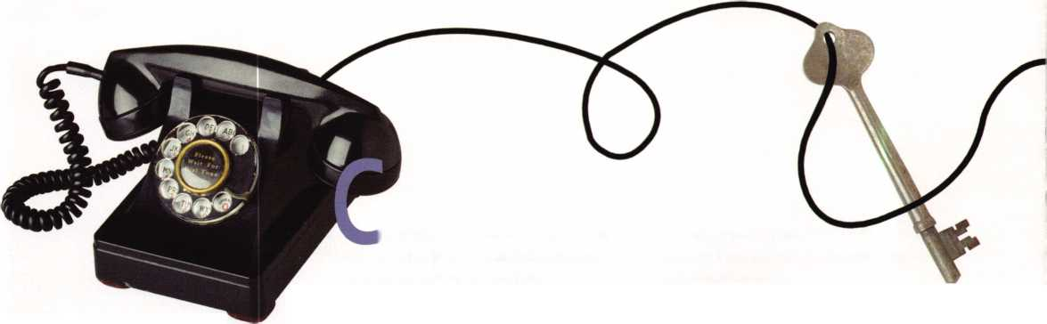

to-order with memory capacity as small as sixteen and as large as two thousand phone numbers. A one to six digit code number is selected for each telephone number that you program into memory. A four-line LCD directory displays the names and code numbers for each occupant. Visitors scroll through the directory listings to find the code for the person, or company, they wish to reach.

Occupants can be issued a PIN number to gain entry or you may connect a card reader to the system. A printer output also allows an audit trail to be generated of all activity. Another option is the clock/calendar module which permits scheduled locking/unlocking times. Access codes or cards may even be programmed to be valid only at selected times and days. These are all features you’d expect from a true access control system.

TEC IV can be programmed in a number of ways. You can enter data right at the unit’s keypad or you can call the unit from a touch- tone phone (remember, the TEC IV has its own phone number) and enter data with the phone touchpad. For very large installations the best option would be to purchase the SES software and use a remote PC with a modem to program the unit.

A number of security features are standard. After a number of wrong attempts the keypad will shut down to discourage PIN guessing. Phone hackers are also thwarted. Only those numbers programmed into the TEC IV memory can be dialed by the unit, meaning nobody can use your line to make expensive long distance calls. A two- level password protocol limits who can program new phone numbers into the system. Visitors only see the designated code number, not the actual phone number of the person they are calling. While the unit is dialing the speaker is muted so that visitors cannot hear the tones and translate these into a phone number.

You may be thinking that these systems are much too complicated for you to install. The opposite is actually true. The engineers who design these things have to be geniuses. The installer’s job is quite simple.

To install a “Select Gate” you need a phone extension line terminated in a standard modular jack. Residential phones use either two or four wires, just follow the color code. To install a TEC IV is even easier. Have your customer call the local phone company and order a new line with a jack located wherever you need it.

The “Select Gate” and the TEC IV come with their own plug-in trans­former which you connect with two wires. You may need to provide a separate transformer or power supply for your electric locking device. A basic hookup for a TEC IV is shown in figure A.

Telephone entry systems offer the locksmith excellent opportunities to provide security and convenience for their customers. The skills required are the same ones needed to install simple, single-door keypad entry controls.

With “Ma Bell” as a partner, how can you fail?

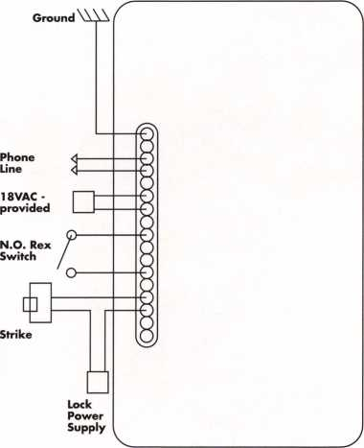

**installation**

**Locksmith Vino Mauri-  
cio, owner of ABC Keys  
in Corpus Christi, Texas,  
installing an S.E.S.**

**telephone entry system.**

interior

view

Keynotes I **21**

February 1999

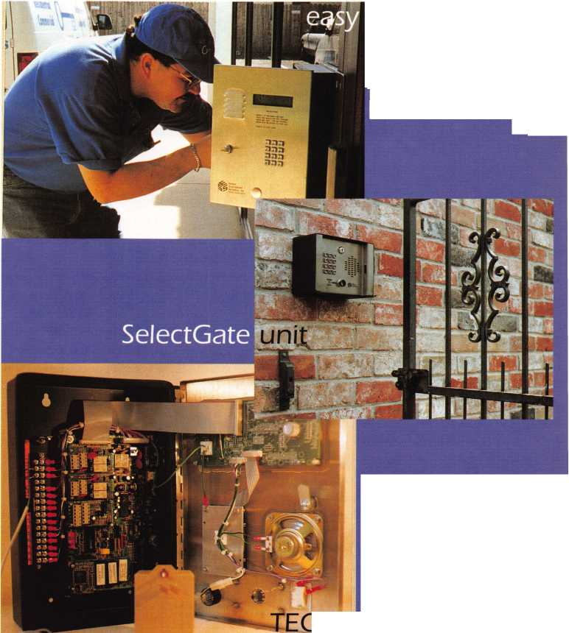

LOCKSMITHING

**The Suzuki Motorcycle**

**By Raymond D’Adamo, CML & Tina D’Adamo, CRL**

This article is written as a documentation and chronology of the Suzuki motorcycle in the US, dating from the late 1970s. The dates specified here are approximate, due to some overlap during transition periods, when Suzuki switched from an existing system to a new one, or introduced and utilized a new system concurrent with an existing one.

Suzuki lockwork is very similar to Yamaha and Kawasaki, and is therefore similarly serviced. Suzuki produces three types of motorcycles: on road, on/off road and off road. Here, the term “motorcycle” applies to two, three and four wheel motorized vehicles without an enclosed passenger compartment. The on road and on/off road models are fitted with a base assortment of locks, namely ignition, helmet, seat and tank. Some models, like the TL1000, do not have a helmet lock, while others, like the Marauder and Intruder may be fitted with additional compartments, so the actual number fitted to the vehicle you service may vary.

When determining whether an auxiliary compartment lock is keyed to a bikes system, we apply these rules. If the compart­



Keynotes

February 1999

ment is part of the stock vehicle, the lock is most likely keyed to the system. If the compartment is not part of the vehicle, like an additional luggage compartment, when the piece is fitted at the factory, then the lock is most likely keyed to the system. If the piece is purchased and installed afterwards, but a piece of Suzuki equipment, then it is only possible that the lock in it is keyed to the system. If the piece is not original Suzuki equipment, then it is very unlikely that the lock is keyed to the system.

The off road, two wheel cycles do not use key locks, but use toggle switches & buttons to enable the lighting, starter and ignition circuits.

The three and four wheel ATVs are usually fitted with an ignition switch lock only.

Code Series: 1111-4555  
1972

Keyblank: SUZ1 through SUZ4

This three pin, three step system represents the earliest with which we have any service experience, and not many Suzukis

sporting it still exist today. Key codes are found stamped into the face of the lock plug. Of the four digits in the key code, the first represents the keyblank, and the last three represent the direct digit bitting sequence from bow to tip.

The Silca Automotive, Truck & Motorcycle Keyblank Identification and Cross-Reference Guide (out of print) has a section in the back, devoted to motorcycles. It is set up chronologically and is very helpful when determining the appropriate keyblank for the key code you may be working with.

Code Series: 101-499  
1978

Keyblank: SUZ11

Fitted in the late 1970s, this five disc, four step, keyed alike system utilizes single throw disc locks, operated by a double bitted, reversible key. All cylinders carry a full complement of discs, and the key code is found in various locations on the locks.

The ignition assembly is either only a

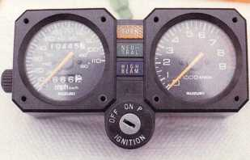

keyed electric switch or a fork locking assembly. The keyed electric switch is either mounted with screws in the console area, or it snaps into the console from the top (photo 1), secured by three prongs extending from its side (photo 2). These prongs are compressed as the switch is inserted into the console. Once the switch is home, the prongs expand to secure the switch in the console. To remove this switch from the console, compress the prongs one by one from beneath the console, slightly tilting the switch up as each prong is compressed, until the switch exits the top of the console. The switch is connected to the wiring harness by a plastic connector. Separate this connector to completely remove the switch from the vehicle.

Either switch can be disassembled from the back to depress the retainer disc at the back of the plug, or put a pick into the plug, pull down the retainer disc located behind the combination discs, and pull the plug from the casing. The key code is stamped into the face of the plug on earlier models, and on later models (photo 3), it is stamped into the side of the switch casing.

The fork locking ignition assembly is a bit more difficult to remove because it is secured with sheerhead bolts. After it is removed, it can be disassembled from the bottom, however, if the lock is working properly, the cylinder plug can be removed with a pick, and the discs decoded, as described in the previous paragraph.

The helmet lock is stamped with the key code either on the face of the plug, or on the back plate, and it can be disassembled or the plug can be removed with a pick, as described earlier. At times, the seat and helmet lock are combined into one assembly.

When it exists as a separate assembly, the seat lock is usually not coded. The plug is secured with a driven pin. Remove the pin to remove the plug.

The gas tank cap (photo 4) contains a lock stamped with the key code on the face of the plug, or on the bottom cover of the cap, as in photo 5 where the key code 425 can be seen just to the right of the left locking latch. The cap can be disassembled, or, as described earlier, the cylinder plug can be removed with a pick (photo 6).

When servicing locking gas tank caps which require disassembly, remember that some of the parts on or inside the cap, such as gaskets, ball bearings, springs and 0 rings, prevent moisture contamination and regulate pressure inside the tank, but if assembled incorrectly, the cap can release noxious gas fumes into the air supply of the operator, and it also could affect fuel delivery to the engine, so keep especially good track of these parts, and make sure they are rein­stalled correctly for safe and efficient operation. We have more about gas tank cap service later in this article.

The fork lock (photo 7) is secured to the vehicle with two screws. When it is unlocked, it can be removed with a Phillips head screwdriver. The key code is stamped into the face of the plug (photo 8), and the lock can be disassembled by removing the plug retainer stake (photo 9) found in a cavity of the lock casing, which is inaccessible until the lock is removed from the vehicle.

Suzuki ATVs  
Code Series: 101-499  
1983-1984  
Keyblank: SUZ11

Code Series: CDEF11224-79897  
1985-1998

Keyblank: YH48, YH49, YH5Q, YH51

Suzuki began producing three wheel ATVs (all terrain vehicles) in 1983, and in 1985 the four wheeled Quadrunner was introduced. The Quadrunner replaced the less stable three wheel vehicle and is still produced today. The Suzuki ATV is fitted with a keyed ignition switch only. The plug face or switch casing are stamped with the key code, as well as the original set of keys. The cylinder plug can be removed with a pick, as described earlier in this article, or, the plug can be removed after removing and disassembling the switch. To remove the switch, unscrew the bezel nut retaining the switch to the console, lower the switch from beneath the console and separate it from the wiring harness at the connection clip. To disassemble the switch, unsnap the terminal plate at the back, remove the rotor, depress the plug retainer and remove the plug.

February 1999

**PHOTO 1**

**PHOTO 2**

**PHOTO 3**

**PHOTO 4**

***Keynotes \*** **23**

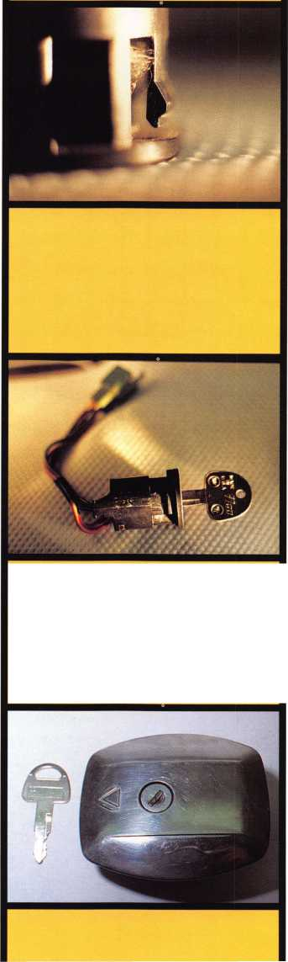

Code Series: CDEF11224-79897

1986

Keyblank: YH48, YH49, YH50, YH51

In 1986, this new keyed alike system was introduced on all two wheel vehicles as well, and it existed in the field for at least two years, along with the system just previous to it. Essentially, this system is the same as that used on the Suzuki ATVs and the Yamaha bikes of the period, and it is thoroughly covered in our Yamaha article published in Keynotes, January, 1997. Please refer to it, for additional information.

Code Series: 6001-7000

1988

Keyblank: SUZ12

In 1988, this new keyed alike system replaced the two previous to it, and existed in the field for at least six years. Though lock construction and service is very similar to the previous two systems, some notable differ­ences exist.

None of the locks in this system are stamped with the key code, however, a code tag does accompany the original set of keys. The cylinder plugs cannot be removed from the keyhole with a pick, so some disas­sembly will be required if a key cannot be manufactured by impression or sight reading from the keyhole. Also, this seven position, four step system marks the first time Suzuki utilizes locks with both full and partial disc content.

The ignition assembly is either only a keyed electric switch or a fork locking assembly. The keyed electric switch is either mounted with screws in the console area, or on the right hand side of the bike. The fork locking assembly is mounted at the console. Either type can be disassembled from the back or bottom, and only it contains all seven system discs. The helmet or seat lock can be disassembled from the back, and these contain the first three discs. The tank lock can be disassembled from the bottom cover, and it contains the last five discs.



Keynotes

February 1999

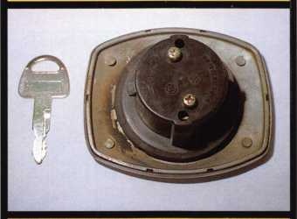

**PHOTO 5**

**PHOTO 6**

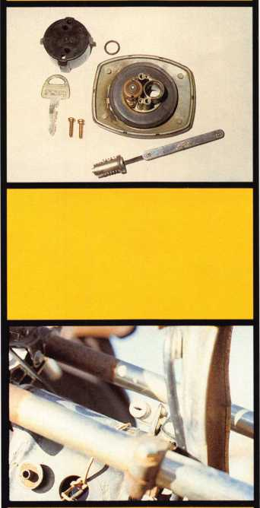

**PHOTO 7**

**PHOTO 8**

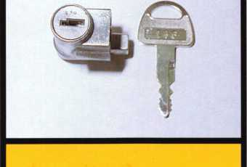

The Independent Fork Lock

Code Series: AA111U-55555  
1986-1998

Keyblank: Y6l

The independent fork lock used during this period, is a pin cylinder mounted in the steering head of the frame on the right hand side of the vehicle (photo 10). It is usually used in conjunction with a side mount ignition switch also seen in photo 10. The fork lock is protected from road contami­nants by a dust shutter, which pivots from a drive pin located just above the cylinder.

This five pin, five step brass cylinder is also used by 28 other cycle manufacturers, making it by far, the most widely used inde­pendent fork lock cylinder in this field. The only key code on it, would be stamped into the side of the bible, a location impossible to see while it is still installed.

To lock the fork, turn the fork to the far left. This will align the locking pin at the back of the cylinder with the strike in the fork. Swing the dust shutter aside, insert the key and turn it until it stops, push the cylinder against pressure from the return spring, into the steering head until it stops, turn the key back until it stops and remove the key. To unlock the fork, reverse the procedure.

To remove the cylinder, the fork must first be unlocked. Pick, impression or shim open the lock from the front and let it move forward under return spring pressure until it rests against the shutter. Next remove the shutter by pulling out the pivot pin. If you use the shutter as a lever to pry out this pin, you risk bending or worse yet, breaking off the shutter. Be careful! We use a shutter and fork lock removal procedure which works well for us on all fork locks of this type. Here are some photographs we took, while removing a Yamaha fork lock, and the procedure for the Suzuki fork lock is the same. First, open the shutter and slip a flat, chisel pointed tool between the shutter and the frame (photo 11) just beneath the drive pin. With a small hammer, drive the tip of

the tool between the shutter and the frame as close to the drive pin as possible. This should raise up the pin enough to grasp it with an appropriate tool and completely remove it. If after this procedure, the pin is still not raised enough to grasp, from under the shutter, use the flat tool as a lever against the frame to raise the pin higher. To prevent the shutter from getting bent, keep the tip of the tool as close to the base of the pin as possible. After the pin and shutter are removed (photo 12), the cylinder and return spring (photo 13) can be removed from the housing.

Code Series: 6001-7000  
1994

Keyblank: SUZ18

In 1994, this new keyed alike system replaced the one previous to it. We have determined that its spacing and depth speci­fications are the same as the previous system, so use HPC code card #CMC71 or equivalent, to generate first keys. None of the locks used in this system are stamped with the key code, however, a code tag does accompany the original set of keys. The cylinder plugs cannot be removed without some disassembly, and this seven position, four step system also utilizes locks with both full and partial disc content.

Though this system is very similar to its predecessor, there are some notable differ­ences. The disc content of the new system cylinders is different, and though the new key blade profile is exactly the same as the old, the new key throat has been greatly lengthened. Finally, the new ignition lock assembly has been manufactured to be virtually bullet proof to the thief, yet friendly to the skilled locksmith.

The set of locks in photo 14 are off a TL1100. It is comprised of an ignition, seat and tank lock. They are accompanied by two keys and a code tag.

The ignition lock is a fork locking assembly, mounted at the console. To disas­semble it, first remove the cap which is secured to the bolt housing by two Phillips

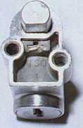

**PHOTO 9**

**PHOTO 10**

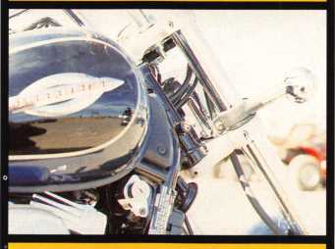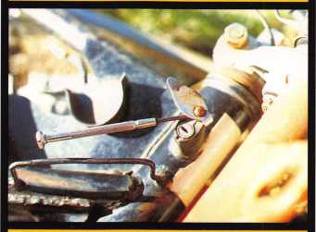

**PHOTO 11**

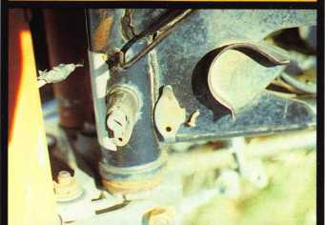

**PHOTO 12**

head screws (photo 13). With the cap removed, lift off the clutched dust shutter, which is designed to prevent screwdriver attacks. With the cap and shutter removed, insert the operating key and with it, push the plug down into the assembly, rotate the plug clockwise to what would be the “off’ position and lift out the plug from the bolt housing. The plug contains eight discs. The first seven are combination discs and the eighth is a disc found only in the ignition. This eighth disc shears with the eighth cut at the tip of the key, which is pre-cut into every operating key and every keyblank. This eighth disc must shear before the plug can be pushed down into the assembly, and the plug must be pushed down into the assembly before it can be rotated to any position. The process of removing the plug can also be accomplished without a key

To remove the plug without an operating key, insert a blank into the plug. This will allow the eighth disc to shear. Inserting a lock pick to shear the disc while applying downward pressure to the plug, will accomplish the same thing. When the eighth disc shears, push the plug down into the housing and hold it down. While keeping the plug depressed, remove the blank or pick and without distorting the keyway, begin to apply light, clockwise rotational pressure to the plug. Next, insert an appro­priate tool into the space between the protruding combination discs and the lock housing. Then, lift all the discs to the shearline while applying slight clockwise rotation to the plug. When all the discs shear, the plug will begin to turn. Turn the plug clockwise to what would be the “off’ position, and lift out the plug from the assembly. The ignition is the only lock containing all seven system discs. Fit a key by decoding the discs. A completely disas­sembled ignition lock can be seen in photo 16. Note the large lug at the bottom of the plug, which also prevents the plug from being turn before it is pushed down fully into the assembly; another and very effective deterrent against screwdriver attacks.

February 1999

Keynotes



The tank lock assembly (photo 17) pivots from a base plate which is bolted to the top of the tank. If disassembly of the tank lock is required, we advise either removing the entire assembly from the tank, or thoroughly taping shut the opening. This will prevent any parts from accidentally dropping into the tank. Begin disassembly by removing the two Phillips head screws at the bottom of the cap (photo 18). Remove the latch cover, latch and return spring. Next, you will find another plate. Remove it.

Next, remove the steel washer covering the rubber 0 ring in back of the cylinder plug. Then, pry out the rubber 0 ring and remove the metal ring below it. Now, the retainer disc is exposed. Depress it and remove the plug from the top of the cap. A completely disassembled tank lock can be seen in photo 19- It contains the last five discs.

The seat lock is retained by two bolts. After removal, disassemble it from the rear (photo 20) by removing two Phillips head screws, a cam and a return spring. The screws hold the plug in the casing. The completely disassembled unit can be seen in photo 21. The plug contains the first four discs.

This vehicle did not have a helmet lock, so its disc content will continue to remain a mystery, perhaps for you to solve on your next Su2uki service request.

See you next time when we look into another exciting facet of motorcycle lock- smithing.

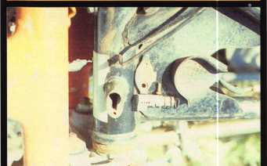

**PHOTO 13**

**February 1999**

Keynotes

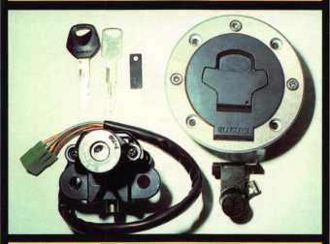

**PHOTO 14**

**PHOTO 15**

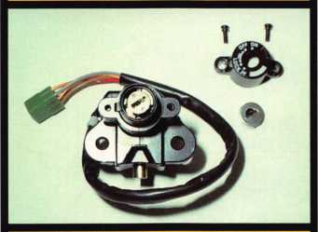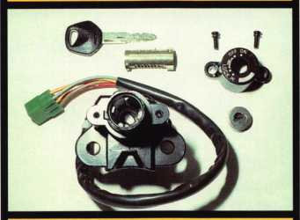

**PHOTO 16**

**PHOTO 17**

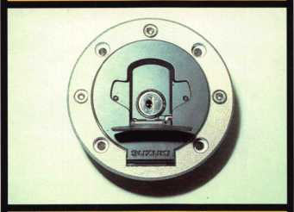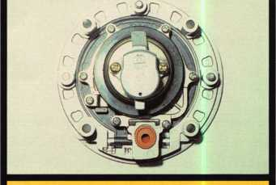

**PHOTO 18**

**PHOTO 19**

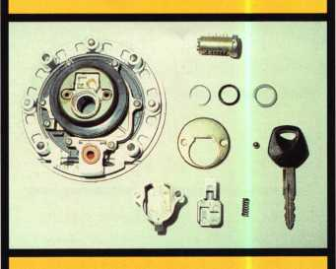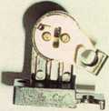

**PHOTO 20**

**PHOTO 21**

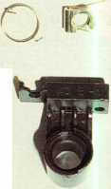

Some years ago, there were the standard motorized code machines in one price range, and the computerized code machines with prices somewhere in the stratosphere. In the last few years, the price differential for some computerized machines has shrunk to just a few hundreds of dollars. Recently, HPC put on a special sales pitch dropping the price of their code machine from the suggested list of over $2000 to a more manageable $1599. Opening up the price advantage quite a bit, made a lot of locksmiths take another look at the model 1200.

The HPC 1200 code machine has always been a very easy to use (and pretty reliable) code machine. The brainchild of Nick Gartner and Tom Swiderick back in the mid 1970s (as the Code-A-Key), HPC took it over and renamed it the “HPC 1200CM” in the late 1980s. It was (and probably still is) the easiest code machine to learn and use.

You could probably get a newly hired locksmith trainee up and running with it in about 20 minutes.

The simplicity and ease of use of the HPC machine has to do with its use of code cards. Instead of having to worry about key cutting specifications measured in thousandths of an inch, all you would need to do is line up space and depth dials to numbered indicator marks found on the various (lock brand identified) code cards. A revision of the 1200CM took place in 1994, with the intro­duction of “The Blitz”. It was then known as the 1200CMB (“B” standing for “Blitz”).

The basic machine remained mostly the same, with a few useful improvements.

Photo 1 shows an HPC 1200CMB “Blitz” code machine. From outward appearances, it looks much like the earlier 1200CM. Some changes/improvements were internal and are not visually identifiable to the casual observer. Most of the changes are best charac­terized as refinements of already useful features. I will explain them (and unchanged features) next. The ease of use found in the HPC 1200CMB can be best identified in photo 2. Here you can see a deck of pre­

printed code cards and the two standard quick change cutters. If you look at the lower (shaded) area of the code cards, you will see two separate arc shaped scales with numbered indicator marks. The upper scale is for cut depths, and the lower scale indicates key cut spacing. Although all brands of locks have set dimensional specifi­cations, you don’t need to use them when cutting keys by code with the HPC machine. If you look closely, you can see that all the cards include the dimensions in thousandths of an inch (and metric- hundredths of a millimeter), if you wish to use or refer to that information. It’s just not required that you use the actual dimensions in order to cut keys. The two standard cutters included with the machine are to the left and right of the deck of code cards in the middle. The CW- 1011 cutter is to the left, and the CW-14MC is to the right.

Photo 3 shows the cutter profiles. Still to the left, the CW-1011 is the narrower cutter. It is used primarily for keys used with disc

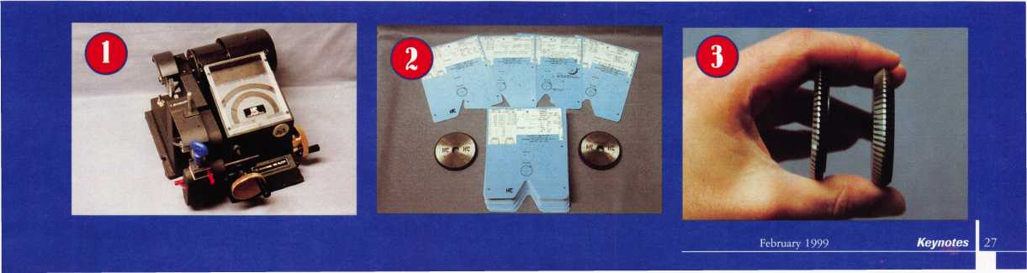

tumbler locks, although certain pin tumbler lock keys will also require this cutter. You will use this cutter mostly for automotive, padlock and cabinet lock keys. The wider CW-14MC cutter (to the right) is used primarily for keys designed for residential and commercial grade pin tumbler locks. There are other specialty (optional) cutters available for certain specific brands/types of keys. The required cutter is normally listed on the code card. All cutters have the same diameter, so that depth adjustment is not required when switching cutters. As a conse­quence, if one cutter is sharpened, all other cutters have to be sharpened (at the same time to keep the same cutter diameters) to maintain a matched set. Depending on how many cutters you have, it could be more economical to buy one cutter, rather than sharpening many cutters. A factory cutter will have the standard diameter.

The two cranks that control lateral (side to side) and depth (in and out) motion can be seen in photo 4. Lateral spacing is accom­plished through the crank at the right side of the machine. Depth control is accomplished through the crank at the front of the machine. Some of the visually non-apparent refinements of the 1200CMB involve the depth and space cranks.

Some years ago, an independent company created a modification kit for the original HPC 1200CM to allow fewer

rotations of the depth crank to move the dial across the depth scale. The kit also replaced the lateral (spacing) crank with a lever handle to more quickly move the dial (and the key vise) side to side. These features of the kit, presumably would speed the process of cutting keys by code with the 1200CM. The Blitz essentially accomplishes the same scale movement efficiency. The depth crank of the Blitz covers the depth scale quicker than that of the earlier 1200CM by at least half. The biggest speed variation (rotation efficiency) goes to the lateral crank. Whereas the 1200CM requires about 14 rotations of the lateral crank to cover the scale, the 1200CMB does it in about four turns.

With a card inserted for Arrow brand lock keys, in photo 5, both dials are set to the left side of the scales. The upper scale is for depth. The dial being to the left indicates that the key vise is away from the cutter wheel. The lower scale is for spacing, and the dial being to the left indicates that the key vise is about as far left as it can be. This is the proper position for inserting a blank key for code cutting. Photo 6 shows the shoulder gauge and standoff rod. It acts as a stop for shoulder gauged keys. The shoulder gauge was part of the 1200CM, but the long rod (standoff rod) attached to it is a refinement unique to the 1200CMB. It makes operation of the shoulder gauge a bit easier and more convenient, when setting a key blank (and

clamping it) in the key vise for code cutting.

Photo 7 shows the blank key in the vise. The standoff rod easily moves the shoulder gauge for key positioning. The key shoulder is up against the stop in photo 8. After tightening the key vise, the shoulder gauge must be moved out of the way before turning on the motor, as in photo 9- You may damage the cutter or shoulder gauge, if the shoulder gauge is in the up position and you try to move the key vise inward or side to side when the motor is running.

With the shoulder gauge out of the way, the key (in the key vise) can be moved in and out, and side to side with the motor running. Side to side motion should not occur when the teeth of the cutter wheel are in contact with the key, unless you are intentionally widening a cut. The motor should never be turned on or off while the key is in contact with the cutter.

Turning the lateral (spacing) crank clockwise will move the pivot arm (on which the key vise sets) to the right. It should be turned until the spacing dial lines up with the indicator mark (on the code card) labeled “1,” which identifies the first space position for an Arrow key. That has been done in photo 10. The depth crank is turned clockwise to move the key closer to the cutter. It has been partially turned in photo 11. Wherever the dial is positioned is the current cut depth. If you rotate too far, you

***Keynotes***

February 1999

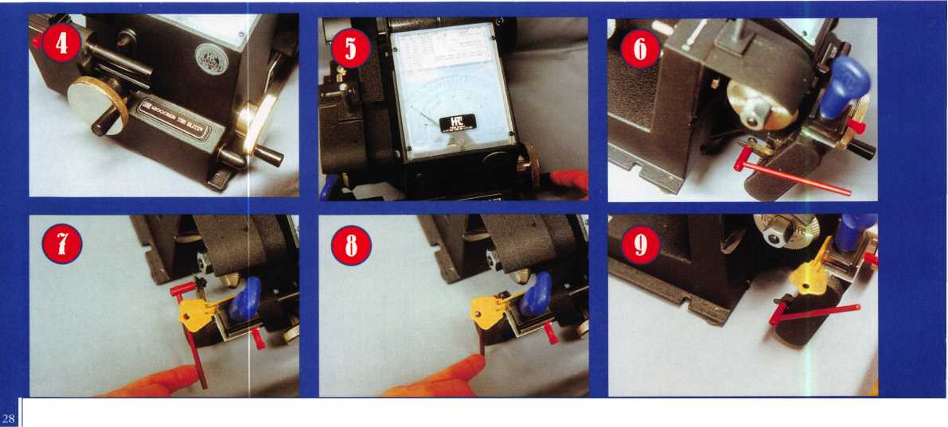

will cut too deep and you will need to start again. When you reach full depth, you must turn the depth crank counterclockwise until the key is out of contact with the cutter. Do not change cut spacing unless the depth dial is shallower than the shallowest allowed depth for the particular brand key. Otherwise side motion will cause the top surface of the key blade to cut while moving sideways.

One by one, each space is positioned.

Depth is cut by turning the depth crank clockwise, and backed off by counterclockwise rotation. When all cut positions are properly cut to depth and the machine is turned off, the key can be removed and deburred.

The key vise has a two sided jaw. Photo 12 shows the standard “A” side of the jaw in place. By removing the wing nut, in photo 13, the top jaw can be removed. The narrow red piece is the tip stop, which fits inside an opening of the bottom jaw. Turning the top jaw around, in photo 14, reveals the “B” side indicator. Photo 15 shows a side view of the top jaw. Code cards will indicate whether the “A” or “B” side of the jaw is needed. When the letter faces up, that side of the jaw is in position. The letter “B” is in contact with my index finger. That side would face up when the “B” jaw was required. The opposite side is the part that comes in contact with the key. Notice a slight ridge at the bottom. The “B” jaw is usually used in one of two ways. For very small keys with very deep cut

depths required, it acts as a lift to bring the key closer to the cutter. This is done so the cutter will cut deeper into the key but not cut into the jaw itself. The “B” jaw is also used with Best (and comparable) keys. In this case, the key does not rest on that ridge (which would move the key closer to the cutter). Instead, the ridge clamps into the bottom surface of the key blade. Best keys have a tendency to tilt in most key vise jaws (because of their groove patterns), and the “B” jaw helps to keep them straight.

Photo 16 shows the single prong red plastic tip stop and a dual prong metal tip stop, sometimes called the horseshoe stop. The horseshoe stop was introduced to deal with some of the longer tip stopped keys that have come along in recent years. Photo 17 shows how the red tip stop fits into the lower jaw. It was used for the H50/H51 double sided five cut Ford keys and a few other tip stopped keys. Lifted to a lower height, it was also designed to work with six cut Best keys. The horseshoe stop, in photo 18, was designed for longer tipped stopped keys and seven cut Best keys. The first prong of the horseshoe stop can work in place of the red stop. Photo 19 shows click stop height positions on the back of both tip stops.

Various adjustment wrenches for the HPC 1200CMB are shown in photo 20. The Allen wrench is used for adjustments of the shoulder gauge. The right side of the top

wrench is for adjusting depth calibration. The left side opening of the wrench at the top of the picture, and the wrench at the bottom are used for changing cutters. The wide end of the one wrench is used to hold the shaft to the right of the cutter wheel, in photo 21.

A 1/2" open end wrench can be used as a substitute. While holding the right side, the other wrench is used on the nut to the left of the cutter, in photo 22. Any 3/4" wrench can be substituted for that one. The nut should be turned clockwise to remove it (left hand thread). If replacing with a new cutter, the nut is turned counterclockwise to re-tighten it. Code cards will identify the correct cutter to be used.

Medeco keys can be cut with the HPC 1200CMB (and CM). A tilting head is standard with the machine, but the Medeco cutter and special key vise are optional items. Photo 23 shows the CW-1012 cutter needed for cutting Medeco keys. Below it is the Medeco jaw. The letters “R” and “L” with arrow in between indicate angle positioning when using the tilting head. A side view of the Medeco jaw, in photo 24, shows a milled groove for gripping standard Medeco keys very low. Medeco has its deepest cut depth as .116". Using a standard jaw would cause damage to the jaw. Cutter angle is changed by pulling out the spring loaded pin in photo 25, and then tilting the head to the left or right.

***Keynotes***

February 1999

|  |  |
| --- | --- |
|  | 1 191  |L *#v., |
|  |  |

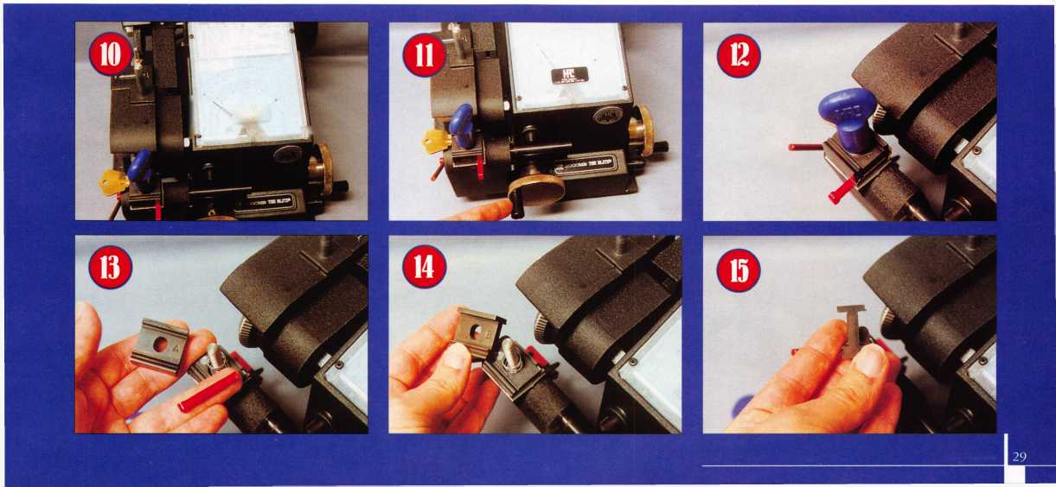

***Code, Cards***

Code cards are what make the HPC 1200CMB so fast and easy to cut keys by code. Originally, the code cards included with a new machine were made by a company called Continental Micro, but now they are made by HPC.

Fast and easy is one thing. In order to be versatile, the machine must come with a wide enough variety of cards to handle the large assortment of locks and keys that a typical locksmith might come across. The HPC 1200CMB includes two large packs of code cards that encompass most brands of residential and commercial pin tumblers locks, pin and disc tumbler cabinet locks, padlocks, domestic and import automobile locks and many others.

A sampling of two code cards can be found in photo 26. To the left is the card for Arrow brand locks. If you look at the bottom half of the card, you will see the labeled depth and space markings. The depth scale (top scale), from left to right, shows Arrow key cut depths from 0 (shallowest) to 9 (deepest). The spacing scale (bottom scale) shows two different numbering patterns. In larger type, at the top of the indicator marks, it is numbered 1 to 6, from right to left.

That would be bow to tip cut listing. In smaller type (and in parentheses), toward the bottom of the indicator marks, it is also

numbered 1 to 6, but from left to right. That is tip to bow listing. Most locksmiths would tend to use bow to tip listing (as is consensus industry standard), but factory cut Arrow keys will often be stamped with key cut bittings listed from tip to bow. The card will allow you to use either method.

Part of the ease of the 1200, is that a beginner can cut keys without being over­whelmed by technical data. Important technical data, however, is included on code cards for locksmiths who wish or need to use it. Back to the Arrow card, you will see depth and space dimensions (in both English and metric measurement) in the upper left hand corner of the card. Just to the right of those dimensions is a diagram of an Arrow key with spacing marked from the key shoulder to the center of the first cut, and cut to cut spacing for the rest of the cut spaces that follow. While the depths are not listed, the depth increment of .014" is identified in the diagram.

As I indicated earlier, all code cards will list the recommended jaw and cutter. The Arrow card lists that information at the top. The “A” jaw and CW-14MC cutter are indicated. Key blank and other useful infor­mation is often also included. Although not specifically indicated, Arrow keys would make use of the shoulder gauge for posi­tioning key blanks in the key vise. The

diagram showing that spacing dimensions are measured from the key shoulder provides a sufficient hint to let you know that the shoulder gauge should be used.

The card at the right, in photo 26, is for Best (and compatible) keys. Various diagrams and notes, on the card, indicate that it uses a tip stop (the second prong of the horseshoe stop, specifically) and the “B” side of the jaw. A diagram shows how the ridge of the “B” jaw grips, rather than lifting, the blade of the Best key blank. All spacing dimensions are measured from a flat vertical surface near the tip end of the key. Best key cuts are more commonly read tip to bow, rather than bow to tip. The indicator marks on the spacing scale are labeled 1 to 7, both right to left and left to right. That allows reading key cuts either bow to tip or tip to bow. The two cards in this picture are a bit unusual (compared to the majority of the other code cards) in that they label cut spacing positions in both directions. Most cards will only be one direction, and the vast majority of those will be bow to tip.

A large variety of different code cards is needed to consider the machine versatile. Even with an extremely large assortment of code cards for virtually every brand of lock, there will always be key cut depth and spacing patterns for which you will not have a specific code card. HPC covers that

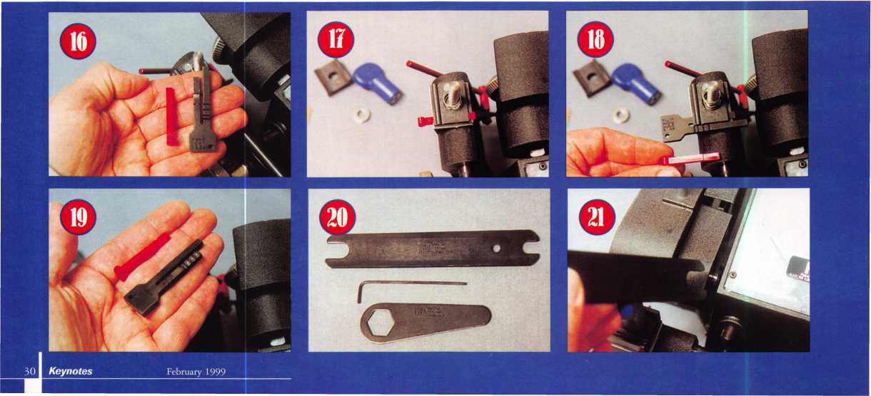

potential shortcoming with a handy  
assortment of micrometer code cards.

Because there are a number of different  
points of reference for the 1200 code  
machine, cards are specific to different  
stop surfaces.

Photo 27 shows two of the various  
micrometer cards. Replacing numbered  
indicator marks are full scales of labeled  
dimensions for both spacing and depth. The  
card at the left is for shoulder gauged keys  
using the “A” jaw. The card at the right is  
also for shoulder gauged keys, except it is for  
keys using the “B” jaw to lift them closer to  
the cutter. Take note that the spacing scale is  
identical for both cards, but the depth scale is

shifted by .040". If you look at the depth  
scale for the “A” jaw card, you’ll see the  
deepest depth to be .140". If you need to cut

keys with depths deeper than .140", you  
should use the “B” jaw and the matching  
micrometer code card which shows you can  
cut as deep as .100".

Two additional micrometer cards are  
shown in photo 28. They are both for tip  
stopped keys. The card at the left is for keys  
using the red tip stop (or left prong of the  
horseshoe stop). The card to the right is for  
keys using the horseshoe tip stop, but  
specifically the right side prong of that tip  
stop. Both require the “A” jaw. Because they  
use the same jaw, the depth scales are

identical. With different stop surfaces, you can see that the spacing scales show different dimensions across the scales. The four micrometer cards shown use inch measure­ments. There are similar micrometer cards with metric dimensions substituted. None of the micrometer cards mentions what cutter to use, because any cutter will work. The diameters and center lines of the cutter profiles are identical for all cutter wheels. Spacing and depth would not be altered by substituting cutters. Only the shape, angle and cut width would vary.

The Blitz added another feature that wasn’t found on the original HPC 1200CM. It’s a deburring wheel, shown in photo 29.

All in all, there were relatively few changes from the original version of the 1200 to the Blitz. When you have a pretty good machine, though, you don’t have to make that many changes.

Both the original HPC 1200 code machine and the Blitz are versatile and easy

to use. When the Blitz was first introduced five years ago, HPC had a program for upgrading older 1200 machines to the Blitz additional features. I believe HPC still offers that program. The HPC 1200CMB code machine should be available from most locksmith supply companies. The $1599 special price was supposed to expire on December 31, 1998. Even before HPC offered the recent special sale price, individual locksmith supply companies have offered it below the list price at very attractive sales pricing. Either way, if you’re looking for a code machine, it wouldn’t hurt to give the Blitz a look. For more informa­tion on the Blitz or other HPC products, contact: HPC Inc., 3999 N. 25th Avenue, Schiller Park, IL 60176.

Phone: (708) 671-6280

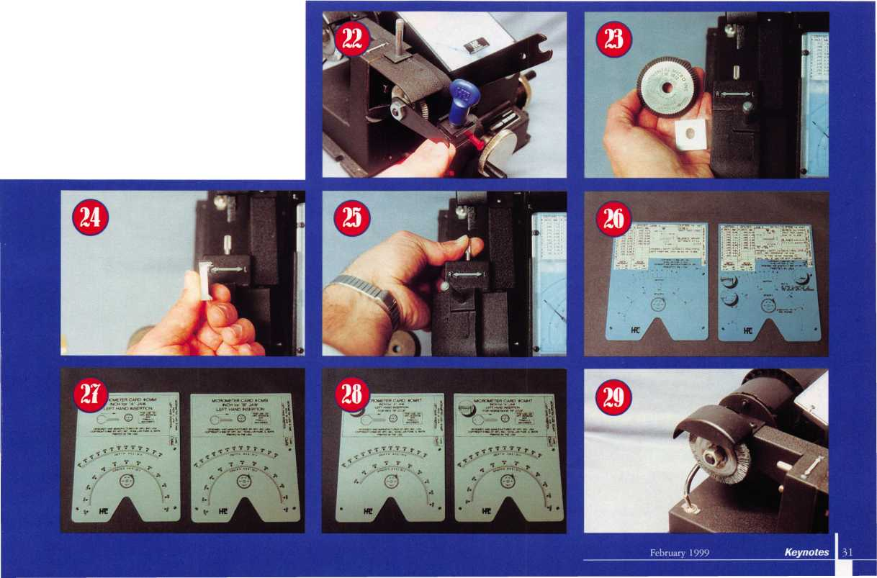

32

enrols

**from**

**by sal Duloamaro, gmi**

PRO-LOK makes a lot of inter-

esting tools for locksmiths. One that was

introduced at the last ALOA trade show, was  
the LT340 IC Rekey/Decoder. Shown in  
photo 1, it is a somewhat impressive all in  
one IC servicing tool. It does the standard  
routine of being a holding fixture for coding  
and capping Best-style cores. It one ups that  
type of device, though, because it is also a  
decoding tool, all in the same basic fixture.

In photo 2, the chamber cap staking plate has been taken off the top and set down to the left of the fixture. Still loosely attached on the right side of the fixture is the sleeve retainer staking plate. With a knurled outer knob, the removable inspection plug has been partially pulled out of the fixture. With individually accessible chambers, the chamber cap staking plate is used with Best brand and compatible style cores that use individually capped pin chambers. The sleeve retainer staking plate is used in conjunction with Falcon style cores that use a single metal cover plate to cover all pin chambers. Both of these parts are intended for coding cores. The removable inspection plug is designed for decoding cores. I will explain that a bit later.

Using the fixture for coding a core, you would load an uncoded Best-style core into the fixture as in photo 3. The clamping knob (thumb screw) at the left of the fixture should be lightly tightened to hold the core in the fixture. The core must be positioned properly and held in place (with the clamping knob) for the chambers of the chamber cap staking plate to align properly with the pin chambers of the core.

It is generally easier to load the tumblers

into the

pin chambers of the core, before you place the chamber cap staking plate on top of the fixture. The tumbler springs and chamber caps can then be installed after the staking plate has been positioned and attached.

A capping punch, called the chamber cap staking pin, is held just above the fixture in photo 4. After making sure that the chamber cap (for a particular pin chamber) is positioned properly, the chamber cap staking pin should be tapped lightly until the chamber cap is properly staked, as in photo 5. The same procedure would be repeated over and over until all pin chambers were capped.

When dealing with Falcon cores that require a single metal strip to cover all chambers at the same time, you would load springs in the chambers following the tumblers. After placing the single metal strip (to cover all pin chambers) on top of the core, the sleeve retainer staking plate would be placed on top and lightly tapped with a hammer.

**Decoding a Bests core**

When you have a filled core, you can usually reuse it by emptying all the pin chambers and starting all over again. If you need to decode the core and figure what (control or other) keys operate, you will also need to unload the pin chambers but keep them in the proper order or sequence so that an accurate key can be made. With the core installed in the fixture upside down, in

photo 6,

the ejector

pin (called

Chamber Cap Removal Pin

by PRO-LOK) points to an access hole on  
the bottom side of the core.

When tapped all the way through, the ejector pin will knock out all the tumblers, spring and the chamber cap. Photo 7 shows a core with the ejector pin pushed all the way through a pin chamber. The openings through which the tumblers will travel can be seen in a top view in photo 8. The removable inspection plug has been pulled out in photo 9- If pins had been in the core, they would be lined up in sequence in each of the chambers in the plug.

Obviously, the tumblers would have to be measured in order to determine their size and to decode the core for fitting keys. A control key can almost always be determined. To determine a master key, an operating change key would usually be needed to determine the master key cuts by process of elimina­tion. The LT340 IC Reykey/Decoder looks like a very useful tool for locksmiths who do IC work. PRO-LOK tools are available from many different locksmith supply companies. If you need more information about this or other PRO-LOK tools, contact:

PRO-LOK, 655 North Hariton Street, Orange, CA 92868-1311 Phone: (714) 633-0681 FAX: (714) 633-0470

February 1999

Keynotes

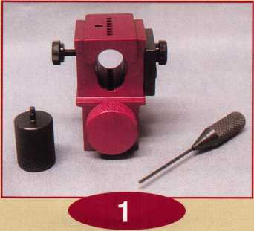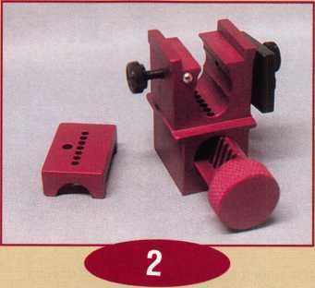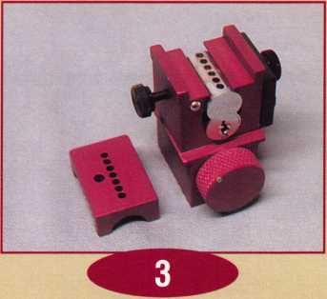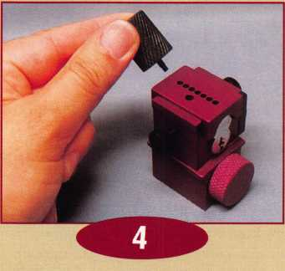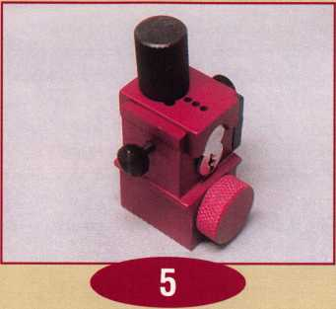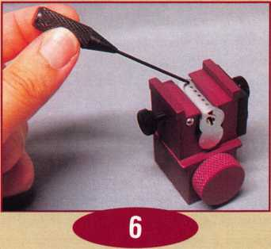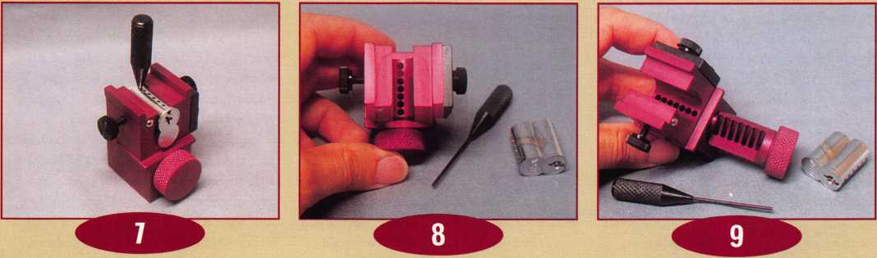

**The LT340 ic eehey/eecoder looks  
like a very useful tnol fur locksmiths  
mho do ic uiork**

February 1999

***Keynotes*** | 33

*(Editor’s Note: Last month, we discussed the visual aspects of a successful shop van including  
lettering, colors and other helpful tidbits in regards to effective aesthetics. This month, we'll delve into  
other areas of maintaining a useful shop van including what kind of words to include on your van,  
advertising costs, use of logos as well as other items to take into consideration.)*

The cost of advertising is tax deductible in most states (check with your local CPA or State Tax representative to make sure). After deciding on the size and color of your lettering and words, begin by pricing the difference between a vinyl lettering applica­tion and installation cost by the local graphic design company in your home town as opposed to the plastic magnetic signs we can order through the mail.

What you’ll find is that the cost varies. Weigh the importance of a professional appearance on your vehicle versus the magnetic sign. There are a number of local graphic art companies located throughout many areas that utilize vinyl lettering of all sizes. They will not charge you an arm or a leg to professionally place your letters and words on your service vehicle. They will also lay out the design on your vehicle. This is usually done in accordance with your vehicle’s available advertising surface space.

In most cases, you can see how your lettering and words will appear on your vehicle by computer generated images. Most graphic design companies have programs that will display for you the different size trucks and vans and possible lettering/word combinations. If you must choose between spending some of your business’ start-up money for a professional job instead of putting a magnetic sign on your truck or shop van, you might consider spending the extra money.

I do not encourage buying those metal and plastic letters at the local hardware store, unless you have a good eye and steady hands.

When I took my shop van to the local graphic art sign company to put lettering on my tmck, the cost of the job was estimated at $300 dollars. It would take the installer one-hour to apply the vinyl lettering to my

A **Keynotes** February 1999

tmck. Being a locksmith (and by habit), I immediately looked at the doors and windows of the company that was doing the work on my van. A quick security inspection told me the owner could better protect his business and property with a few well-placed dead bolts and window locks. I asked the owner when was the last time he had a security inspection of his business and property and had his locks rekeyed. He couldn’t remember, so I immediately proceeded to give him a free security inspection update at

*u*

You’re a locksmith,  
that’s what you do  
for a living. Be proud  
of it and let your  
community know that  
when they first see  
your service vehicle.

no cost. I also recommended additional security measures for his property. At the end of this inspection, I asked him if we could work out a deal. For the cost of two dead bolt lock sets, the rekeying of six key in knob cylinders, three window locks, and five new keys, the cost of lettering my van was a handshake and a new friend for life.

As I was leaving, I also asked him for a stack of his business cards to promote his business to my friends who had vans and trucks that could use his services. When I purchase my next shop van, it will be going back to the same place for another lettering job. Likewise, he’ll probably be consulting me on any lock or security needs.



**By Michael Ferrlll**

After selecting the right graphics company, lettering and colors, the last (and most important) thing to consider is what words to place on your van.

First of all, tell them who you are. You’re a locksmith, that’s what you do for a living. Be proud of it and let your community know that when they first see your service vehicle. List your other qualifications, and the products you sell and service.

When I see the words “locks and keys,” I think of the local hardware store down the block that cuts keys and sells the locksets in my neighborhood. I am not saying you shouldn’t use “lock and keys,” but there are additional words you can use that will be professional and straightforward in your presentation of services that you can provide to your community. Your honesty and integrity is on the line. If your business has expanded into the numerous areas now involved in the security industry, then place this information on your shop van.

Use your telephone number. If you have more then one telephone number, list them both. If you have a fax number, you may want to put this number on your business card. Most importantly, if you list a 24 Hour Emergency Telephone Number, make sure that you highlight this number on your service vehicle as the number to call. I’ll offer one word of caution, however. When you get that call at 2:30 am to unlock anything downtown or in the middle of nowhere, be prepared to go. You listed that service on your shop van, and the customer is counting on you to be there to help them.

Also, display your locksmith membership affiliations. Use the ALOA logo or state that you’re a member. If you are a member of your state locksmith association, then place the decal on your shop van. Your customer

may recognize this organization. If he doesn’t then during your first minutes with him, point that information out to him when you identify your self as a Locksmith

When displaying logos on your vehicle be sure you do not violate copyright laws. The logo that I used on my Locksmith van is a lighthouse. Remember, I live on an island that’s in the Atlantic Ocean and it is a recog­nizable local landmark. I can’t begin to tell you the number of calls that I get from the customer asking me, “Are you the guy in the white locksmith tmck with the light house on it?” If your area has a identifiable landmark that has not been copyrighted yet (i.e. the University of Notre Dame Golden Dome, The Empire State Building), consid­ering placing it on your shop van. Keys, locks, and safes are also acceptable logos to place on your van. Use a little common sense and place them in the right spots.

You may also consider listing company’s you use and represent. It’s unfortunate that many companies like Baldwin, Schlage, Yale, and Medeco, don’t have vinyl logo’s to give to their locksmiths and their national, regional, and local distributors. A lot of these company names are copyrighted and protected and can not reproduced at your local graphics design arts shop. What a great idea it would be if the marketing manager of

a national lock or door hardware company ordered and distributed the company logo’s to those certified and qualified area locksmiths free at the next locksmith trade show in your area. These products could be advertised on the local locksmith shop van, for free and the locksmith could identify this product as one that he sells and services.

Give some careful consideration when applying any logos to your shop van. If you can’t sell, service, or repair this product then leave it off. Nevertheless, take advantage of those free identifiable landmarks in and around your area. You can also make up your own, with help again at the local graphics design shop.

I hope you can use this information.

When you first start out in this rewarding and proud profession, don’t be afraid to ask the other person for help and assistance. Mr. Warren Valero and his son Ken Valero, (the only other two professional locksmiths on the Island of Nantucket) were always there to help me with questions and advice. If you are sincere and honest with the other locksmith and need his help and experience, he will share his knowledge with you. By helping each other in this industry our numbers will continue to grow, and will become more professional. Good luck on lettering your locksmith van.

] NAM) LOCKSMITH

SQNDEt . ;cSS£0 INSURED

(508) 2284762

auhwwm* - Boats - Piaoes

Words commonly used in  
our industry today are:

Alarms and Security Systems Total Home Security  
Safe Sales and Service Licensed Bonded & Insured  
Same Day Service 24 Hour Emergency Service  
Fast Reliable Service Auto-Residential Commercial  
Foreign/Domestic Auto Window Guards and Locks  
Auto Lockouts Our Specialty Full Service Locksmith  
Access Control Systems Master Key Systems

Factory Trained Technicians Fully Insured

Steel Security Bars & Gates Emergency Service  
Door & Fire Exit Devices New Installations

Locks Changed & Keys Made  
Safe Combination Changes  
Fast Service & Reasonable Rates  
Burglar Alarms Installed & Serviced  
Locks Rekeyed Repaired & Installed  
Free Estimates & Security Inspections

**Embark on an Educational and Informative Journey**

It's time again for the annual Southern Lock BUYERS TRADE SHOW. Join us at the Coliseum in downtown St. Petersburg, on Sunday, March 21, 1999, and enjoy an opportunity to chat with manufacturers'reps, fellow locksmiths, as well as the entire Southern Lock crew. Be there Saturday, March 20th, and attend one or more of the classes and seminars. The weather's great and there's plenty to do nearby, so bring the family and turn your educational endeavor into a vacation!

The Southern Lock Buyers Trade Show has become an annual Florida tradition, eagerly awaited by security professionals from all over the country. Make plans now to attend the event that gets better every year! Call our main warehouse - toll free - to register.

**<5rc**

JOCK.

£, snpc

& SUPPLY CO.

800-282-2837

FAX: 800-447-2299

P.O. Box 1980; PineUas Park. FL 33780-1980 e-mail: [sales@southemlock.com](mailto:sales@southemlock.com) [www.southemlock.com](http://www.southemlock.com)

JOIN US FOR/.

• Tlw biggest discounts of the year!

* Door prizes every hour! • Plenty of food and drink!
* Product demonstrations! • Classes and Seminars!
* Manufacturers' reps available to answer your questions!
* The Latest in Electronic Access • Ail of this and its FREE!

Serving the Security Industry Since 1946.

February 1999

Keynotes

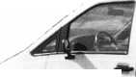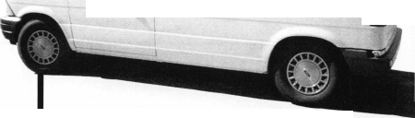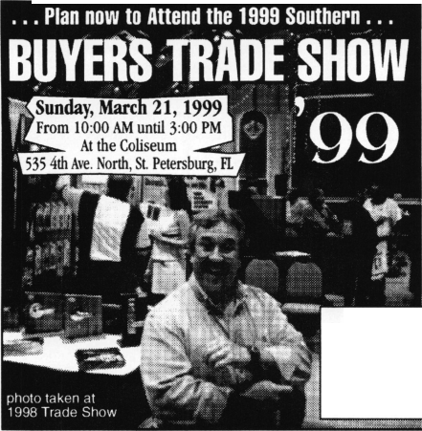

Associate

Members

|  |  |
| --- | --- |
| RfflfflDDDOfeceOQDDtBffS | Arrow Lock Company  10300 Foster Avenue  Brooklyn, NY 11236 (718) 257-4700; FAX (718) 649-9097 |
|  | a a a a |
| A & B Safe Corp.  171 S. Delsea Dr.  Glassboro, NJ 08028 (800) 253-1267; FAX (609) 863-1208 | Auto Security Products (A. S. P.)  P.0. Box 10  Redmond, WA 98073-0010 (425) 556-1900; FAX (425) 558-1205 |
| • • • • | a a |
| ASSA Inc.  10300 Foster Ave.  Brooklyn, NY 11236 (800) 235-7482; FAX (718) 257-2772 | BWD Automotive  900 Ravenwood Dr.  Selma, AL 36701  (334) 874-9001; FAX (334) 874-6011 |
| • | a a |
| Abus Lock Company  3555 Holly Lane North  Plymouth, MN 55447-0507 (800) 352-2287; FAX (612) 509-9939 | Chicago Lock Company  10100 88th Ave.  Pleasant Prairie, Wl 53158-0069 (800) 445-3204; FAX (414) 947-7178 |
| • | a |
| Adams Rite Manufacturing Co.  P.0. Box 1301  LaPuente, CA 91749-1301 (562) 699-0511; FAX (562) 699-5094 | Corbin Russwin Architectural Hardware  P.O. Box 25288  Charlotte, NC 28229 (800) 543-3658; FAX (800) 447-6714 |
| ease | a a a a |
| Adesco Safe Manufacturing Co.  web: [www.adesco.com](http://www.adesco.com) email: [sales@adesco.com](mailto:sales@adesco.com) (800) 821-6803; FAX (562) 408-6427 | Curtis Industries  6140 Parkland Blvd, Ste. 300  Mayfield Heights, OH 44124-4103 (800) 555-5397 |
| • | a a |
| Adrian Steel Company  web: [www.adesco.com](http://www.adesco.com) email: [sales@adesco.com](mailto:sales@adesco.com) (800) 677-2726; FAX (517) 265-5834 | DETEX  302 Detex Dr.  New Braunfels, TX 78130 (800) 729-3839; FAX (830) 620-6711 |
| • | a a a a |
| Alarm Lock Systems, Inc.  345 Bayview Ave.  Amityville, NY 11701 (800) ALA-LOCK; (516) 789-3383 | Don-Jo Manufacturing, Inc.  P.O. Box 929  Sterling, MA 01564 (508)422-3377; FAX (508) 422-3467 |
| • | a a |
| Aiphone Intercom Systems  1700-130th Avenue, NE  Bellevue, WA 98005 (425) 455-0510; FAX (425) 455-0071 | Door Controls International  2362 Bishop Circle East  Dexter, Ml 48130  (800)742-3634; FAX (800) 742-0410 |
| a a • | a a a a |
| American Lock Co.  3400 West Exchange Road  Crete, IL 60417-2099 (708) 534-2000; FAX (708) 534-0531 | ESP Lock Products, Inc.  375 Harvard Street  Leominster, MA 01453 (978)537-6121; FAX (978) 534-9109 |
| a a | a a |
| American Security Products (AMSEC)  11925 Pacific Ave.  Fontana, CA 92337-6963 (800) 423-1881; FAX (909)685-9685 | Folger Adam Security, Inc.  16300 W. 103rd Street  Lemont IL 60439  (630) 739-3900; FAX (630) 739-6138 |
| a a | a a |
|  |  |



Associate members of the Associated Locksmiths of America (ALOA) manufacture or distribute materials or equipment, or provide services, for the security industry. Many have donated money, services and equipment to ALOA in addition to their annual dues. Their support of ALOA projects enhances overall membership benefits and we encourage our members to patronize these firms. If you know of a potential candidate for associate membership, please contact the ALOA Membership staff at (800) 532-ALOA. Associate member dues are $500 per year and entitle the payor to use the ALOA logo, and selected discounts on ALOA products and services.

**L**egen**d**,v

O Alarms: Personal, vehicle, electronic, fire, burglar, and exit

chains/rings

Lockout equipment, key

Builders Hardwares Door closers, furniture/decorative hardware, viewers, emergency exit devices

Books, reference guides, publications, computer software

**9** CCTV/Photo Imaging: Cameras, monitors, photo ID equipment, cables

**9** Electric/Electronic Security: Card access control and readers, surveil­lance, electric/magnetic locks and strikes, keypads

Lock Devices: Auto locks, cylinders, emergency exit/entrance control, locks (various types), strikes

Tools & Supplies: Key blanks, cutters, picks, rings/hooks, custom van/truck supplies



***Keynotes***

February 1999

|  |  |  |
| --- | --- | --- |
| Fort Lock Corp.  3000 N. River Rd.  River Grove, IL 60171 (708) 456-1100; FAX (708) 456-9476 | La Gard, Inc.  3330 Kashiwa Street  Torrance, CA 90505 (310) 325-5670; FAX (310)325-5615 | Rutherford Controls Inc.  2697 International Pkwy, Bid 5 #100  Virginia Beach, VA 23452 (757) 427-1230; FAX (757) 427-9549 |
| •••••• | • • • | • |
| Grobet File Co. of America  750 Washington Ave.  Carlstadt, NJ 07072 (800) 962-7242; FAX (800) 243-2432 | Lori Lock  P.O. Box 1040  Southington, CT 06489 (860) 621-3605; FAX (203) 621-5972 | STRATTEC Security Corp.  3333 W. Good Hope Rd.  Milwaukee, Wl 53209 (414) 247-3333; FAX (414) 247-3329 |
| 9 | • • | 9 9 9 |
| H.E.S., Inc.  2040 W. Quail Ave.  Phoenix, AZ 85027 (602) 582-4626; FAX (602) 582-4641 | Lucky Line Products  7890 Dunbrook Rd.  San Diego, CA 92126 (619) 549-6699; FAX (619) 549-0949 | Sargent & Greenleaf, Inc.  P.O. Box 930  Nicholasville, KY 40340-0930 (606) 885-9411; FAX (606) 887-2057 |
| 9 9 9 | • | 9 9 9 9 |
| HPC, Inc.  3999 N. 25th Avenue  Schiller Park, IL 60176 (847) 671-6280; FAX (847) 671-6343 | M.A.G. Engineering & Mfg. Inc.  15261 Transistor Lane  Huntington Beach, CA 92649 (714) 891-5100; FAX (714) 892-6845 | Schlage Lock Co.  1915 Jamboree Suite 165  Colorado Springs, CO 80920 (800) 847-1864; FAX (800) 452-0663 |
| • • • | • • • | • • |
| llco Unican  400 Jeffreys Road  Rocky Mount NC 27804 (919) 446-3321; FAX (919) 446-4702 | MARKS USA  5300 New Horizons Blvd.  Amityville, NY 11701 (516) 225-5400; FAX (516) 225-6136 | Schwab Corporation  3000 Main St.  Lafayette, IN 47903-5088 (765) 447-9470; FAX (765) 447-8278 |
| • •••••• | 9 | 9 |
| In Out Systems, Inc.  3650-B Matte Boulevard  Brassard, Quebec J4Y-2Z2, Canada (514) 444-5949; FAX (514) 444-2029 | MUL-T-LOCK USA, Inc.  300-1 Route 17 South Suite A  Lodi, NJ 07644  (800) 562-3511; FAX (973) 778-4007 | Securitron Magnalock Corp.  550 Vista Blvd.  Sparks, NV 89434  (800) 624-5625; FAX (702) 355-5636 |
| • • | • • • | • 9 |
| Intellikey  551 S. Apolo Boulevard, Suite 204  Melbourne, Florida 32901 (800) 226-0703; FAX (407) 724-0811 | Master Lock Company  2600 North 32nd Street  Milwaukee, Wl 53211 (414) 444-2800; FAX (414) 449-3114 | Security Door Controls  3580 Willow Lane  Westlake Village, CA 91361 (805) 494-0622; FAX (800) 959-4732 |
|  | 9 9 | • |
| Jet Hardware Mfg. Co.  800 Hinsdale Street  Brooklyn, NY 11207 (718) 257-9600; FAX (718) 257-0973 | Medeco Security Locks  P.O. Box 3075  Salem, VA 24153  (540)380-5000; FAX (540) 380-5010 | Security Solutions  1640 W. Hwy. 152  Mustang, OK 73064 (405) 376-1600; FAX (405) 376-6870 |
| • | • • • | • • • |
| KABA High Security Locks  P.O. Box 490  Southington, CT 06489 (860) 621-3601; FAX (860) 621-9727 | Meilink Safe Company  111 Security Parkway  New Albany, IN 47150 (800) 634-5465; FAX (800) 896-6606 | Sentry Group  900 Linden Ave.  Rochester, NY 14625-2784 (716) 381-4900; FAX (716) 381-8559 |
| • | • | • |
| KEY-BAK; Div. of W. Coast Chain Mfg. Co.  1460 S. Balboa Ave.  Ontario, CA 91762 (909) 923-7800; FAX (909) 923-0024 | NKL Industries Ltd.  1111-13 Cavalier Blvd.  Chesapeake, VA 23323 (800) 528-9900; FAX (757) 485-0271 | Sully Tools Inc.  3515 Nodding Pine Ct.  Fairfax, VA 22033  (703) 689-3416; FAX (703) 787-0869 |
| • • • • | • 9 9 9 | 9 9 9 |
| Knaack Manufacturing Co.  420 E. Terra Cotta Ave.  Crystal Lake, IL 60014 (800) 456-7865; FAX (815) 459-9097 | National Cabinet Lock  200 Old Mill Road, P. 0. Box 200  Mauldin, SC 29662 (864) 297-6655; FAX (864) 297-9987 | TIB Canada Ltd.  2164 Oneida Crescent  Mississauga, Ontario, Canada L5C IV6 (905) 566-9198; FAX (905) 566-9697 |
| • | • | 9 9 9 9 9 |
| LAB Security  700 Emmett St.  Bristol, CT 06010  (800) 243-8242; FAX (203) 583-7838 | Newman Tonks  805 N Buckman St.  Shepardsville, KY 40165 (800) 826-5792; FAX (800) 777-8229 | Taymor Industries, Inc.  1586 Zephyr Ave.  Hayward, CA 94544 (800) 388-9887; FAX (800) 288-8133 |
| • | • 9 | • • |
| LCN Closers (Division of Ingersol)  121 W. Railroad Ave.  Princeton, IL 61356 (815) 875-3311; FAX (815) 875-3222 | ROFU International Corp.  2004-B 48th Ave.; Court E  Tacoma, WA 98424 (800) 255-7638; FAX (253) 922-1728 | Trine Products Corporation  1430 Ferris Place  Bronx, NY 10461  (718) 829-4796; FAX (718) 792-9127 |
| • | • • • | 9 9 9 |
|  |  |  |

Keynotes 137

February 1999

|  |  |  |
| --- | --- | --- |
| Weiser Lock Company  6700 Weiser Lock Blvd.  Tucson, AZ 85746  C502) 741-6338; FAX (520) 741-6363  • 9 | DiMark International  3117 Liberator St, Unit A  Santa Maria, CA 93455 (800) 235-2435; FAX (805) 928-8034  • • | Hardware Agencies, Ltd.  1220 Dundas Street East  Toronto, ON M4M 1S3 (416) 462-1921; FAX (414) 462-1922 |
| Yale Security Inc.  P.O. Box 25288  Charlotte, NC 28229-8010 (800) 438-1951; FAX (800) 338-0965  • • • • | Dire’s Lock & Key Co.  2201 Broadway  Denver, CO 80205  (303) 294-0176; FAX (303) 294-0198  ••••••••••• | Hardware Suppliers of America  P.O. Box 2208  Winterville, NC 28590 (800) 334-5625; FAX (800) 334-5635  • 9 |
| Zhongshan Hua Feng Lock Products  S Yongning Industrial Road, Ziaolan Zhongshan Guangdong, China  86-760 227 82 63; FAX 86-270 227 80 63  • | Direct Security Supply, Inc.  36 Lincoln Street  Boston, MA 02135 (800) 252-5757; FAX (800) 452-8600  ••••••• | IDN, Inc.  1000 S. Main, Suite 280  Grapevine, TX 76051 (817)421-5470; FAX (817) 421-5468  •••••••••• |
| Distributors | Doyle Lock Supply  2211 W. River Road N.  Minneapolis, MN 55411 (800) 333-6953; FAX (612) 521-0166  ••••••••••• | Intermountain Lock & Supply Co  3106 South Main Street  Salt Lake City, Utah 84115 (800) 453-5386; FAX (801) 485-7205  •••••••••• |
| Accredited Lock Supply Co.  P.O. Box 1442  Secaucus, NJ 07096-1442 (800) 652-2835; FAX (201) 865-5031  ••••••• | Dugmore & Duncan Inc.  30 Pond Park Rd.  Hingham, MA 02043 (888) 384-6673; FAX (888) 329-3846  ••••••• | JLM Wholesale, Inc.  3095 Mullins Ct  Oxford, Ml 48371-1643 (800) 522-2940; FAX (800) 782-1160  9 9 9 |
| Ace Lock & Security Supply Co.  565 Rahway Ave.  Union, NJ 07083-6631 (800) ACE-LOCK; (800) ACE-FAX4  •••••••• | E. L. Reinhardt Co., Inc.  3250 Fanum Road  Vadnais Heights, MN 55110 (800) 328-1311; FAX (612) 481-0166  999999 | Jo-Van Distributors Inc.  929 Warden Ave.  Scarborough, Ontario MIL 4C6 (416) 752-7249; FAX (416) 752-3845  ••••••••••• |
| Akron Hardware Consultants, Inc.  2579 South Arlington Road  Akron, OH 44319  (800) 321-9602; FAX (800) 328-6070  see | Ewert Wholesale Hardware  4709 W 120th St  Alsip II 60658  (800) 451-0200; FAX (708) 597-0881  9 9 9 • 9 | Lockmasters, Inc.  5085 Danville Road  Nicholasville KY, 40356 (606) 885-6041; FAX (606) 885-7093  • • 9 9 |
| American Security Distribution  4411 E. La Palma  Anaheim, CA 92807 (714)996-0791; FAX (714) 579-3508  ••••••• | Fairway Supply, Inc.  2631 Lombardy Lane  Dallas, IX 75220  (214)350-0021; FAX (214) 352-4299  ••••••• | Locks Company  2050 N.E. 151 St.  N. Miami, FL 33162 (800)288-0801; FAX (305) 949-3619  ^ ^ ^ ^ ^ ^ ^ |
| Andrews Wholesale Lock Supply  544 S. 9th St.  Lebanon, PA 17042-6608 (717) 272-7422; FAX (717) 274-8679  • | Foley-Belsaw Company  6301 Equitable Road  Kansas City, MO 64120 (800)821-3452; FAX (816) 483-5010  9 9 9 9 | The Locksmith Store Inc.  1229 E Algonquin Rd. Suite E  Arlington Heights, IL 60005 (847) 364-5111; FAX (847) 364-5125  © © © © |
| Boyle & Chase Inc.  P. 0. Box 74  Accord, MA 02018-0074 (800) 325-2530; FAX (800) 205-3500  • • • | Fried Brothers, Inc.  467 N. 7th St.  Philadelphia, PA 19123 (800) 523-2924; FAX (800) 541-3489  •••••••••• | M. Zion Company  69 Reade Street, 4th Floor  New York, NY 10007 (212) 349-8677; FAX (212) 964-0495  ••••••• |
| Clark Security Products, Inc.  4775 Viewridge Ave.  San Diego, CA 92123-1641 (800) 854-2088; FAX (619) 974-5284  •••••••••• | HS&S Wholesale Distributors  12915 West 8 Mile Road  Detroit Ml 48235  (800) 521-2202; FAX (313) 342-7580  @ (|| ^ | McDonald-DASH Locksmith Supply  5767 E. Shelby Dr.  Memphis, TN 38141 (800) 238-7541; FAX (901) 366-0005  •••••••• |
| Cook’s Building Specialties  2441 Menaul Blvd. NE; P.O. Box 37320 Albuquerque, NM 87176-7320 (505)883-5701; FAX (505) 883-5704  •••••• | Hans Johnsen Company  8901 Chancellor Row  Dallas, IX 75247  (214) 879-1550; FAX (214) 879-1530 | McManus Locksmith Supply, Inc.  P.O. Box 9231,1309 Central Ave.  Charlotte, NC 28299 (702) 333-9112; FAX (704) 332-8664  9 9 9 |
|  |  |  |
| ‘ ® Business/Tech & Ed. a _ . „ _ ..  © Bank Security Equipment © CCTV/Photo Imaging £ Safes/Vaults  ® Automotive 9 Electric/Electronic Security Z nthn.  • BuUders Hardware ©Lock Devices ©Other ~ §||Jil| | | |

***Keynotes***

February 1999

|  |  |
| --- | --- |
| McMaster-Carr Supply Company  600 County Line Rd,  Elmhurst IL 60126-2081 (630) 833-0300; FAX C630) 834-9427  •••••• | Service |
| Monaco Lock Co.  339-345 Newark Ave.  Jersey City, NJ 07302 (800) 526-6094; FAX (800) 845-LOCK  • • • | Alarm Monitoring Service, Inc.  5021 Fairfield St.  Metairie, LA 70006 (504) 454-2163; (504) 456-8737  m |
| Omaha Wholesale Hardware  1201 Pacific Street, PO Box 3628  Omaha, NE 68108 (800) 238-4566  •••••••• | Allstate Insurance Company  2775 Sanders Road, Suite A5  Northbrook, IL 60062 (847) 402-8196; FAX(847) 326-7509  • |
| Security Lock Distributors  40 A Street  Needham Heights, MA 02194 (800) 847-5625; FAX (800) 878-6400  • • • | GEICO  One Geico Blvd.  Fredericksburg, VA 22412 (540) 286-4399; FAX (540) 286-7106  • |
| Sentry Security Fasteners  8109 N. University  Peoria, IL 61615  (309) 693-2800; FAX (309) 693-2872  • • | The Hartford Financial Services Co.  55 Farmington Ave.; P.O. Box 2908  Hartford, CT 06104 (860) 520-2915; FAX (860) 520-2264  • |
| Southern Lock and Supply Co.  Box 1980,10910 Endeavor Way  Pinellas Park, FL 33780 (800) 237-2875; FAX: (800) 447-2299  ••••••••• | Locksmith Publishing Corp.  850 Busse Hwy.  Park Ridge, IL 60068 (847) 692-5940; FAX (847)692-4604  • |
| Stone & Berg Wholesale  99 Stafford Street  Worcester, MA 01603 (800) 225-7405; FAX (800) 535-5625  •••••••••• | The National Locksmith Magazine  1533 Burgundy Parkway  Streamwood, IL 60107 (630) 837-2044; FAX (630) 837-1210  • |
| Strauss Safe & Lock Company  1801 Second Avenue  Des Moines, IA 50314 (515)288-9571; FAX: (515)288-9752  •••••• | Pine Technical College  1000 4th Street  Pine City, MN 55063 (800)521-7463; FAX (320) 629-7603  • |
| Timemaster, Inc.  127 SE 29th Street  Topeka, KS 66605  (785) 232-8705; FAX (800) 798-8463  ••••••• | Unlocks, Inc.  3505 Tarpon Woods Blvd. G409  Palm Harbor, FL 34685 (800) UNLOCKS; FAX (813) 787-7960 |
| Top Notch Distributors, Inc.  3151 Goni Rd.  Carson City, NV 89706-7922 (800) 722-4210; FAX (800) 248-3620  • • • |  |
| Turn 10  P. O. Box 746  Marietta, OH m45750 (800) 848-9790; FAX (800) 391-4553  • • |
| U.S. Lock Corporation  77 Rodeo Drive  Brentwood, NY 11717 (800) 925-5000; FAX (800) 338-5625  • • • • • |
| Webster Safe & Lock Company, Inc.  3020 Millbranch  Memphis, TN 38116 (901) 332-2911; FAX (901) 332-2878  • •••••• |
|  |

It pays

to have new faces  
in the crowd.



During 1999  
each ALOA member  
who sponsors  
a new applicant  
will receive $40 in  
Convention Bucks  
(upon clearance,  
and payment of  
application fee and dues).

February **1999**

Keynotes 139

A

Keynotes

Classified



Dept

Classified Advertising Policy

**Classified advertising space is provided free of charge to ALOA members, and for a fee of $.60 per word, $15 minimum for non-members. Classified ads may be used to advertise used merchandise and overstocked items for sale, “wanted to buy” items, business opportunities, employment opportunities/positions wanted and the like. Members or non-members wishing to advertise services or new merchandise for sale may purchase a “Commercial Classified Ad,” for a fee of $1.30 per word, with a minimum of $40. Each ad will run for two issues. For blind boxes there is a $5 charge to members and non-members. All ads must be submitted in writing to the ALOA office by the fifteenth of the month, two months prior to issue date. Send to Keynotes Classifieds, 3003 Live Oak St., Dallas TX 75204-6186. ALOA reserves the right to refuse any classified advertisement that it deems inappropriate according to the stated purpose of the classified advertising section.**

■ EMPLOYMENT Locksmith Wanted

2/F/3: Southwest Detroit estab­lishment of 55 years seeking employees for inside and outside help. Inside help must have one year experience. Outside help must have one year experience and good driving record. We only work with commercial accounts. Uniforms will be pro­vided, BCBS, hourly wages. Can move up to salary. Sick days and vacation days are paid for. Outside help will have full ser­vice van. Please, serious people only apply.

Fax resume to:

(313) 894-7586

Locksmith Wanted

2/F/3: Land of Milk and Honey. Minneapolis-based lock compa­ny looking for experienced tech­nician (minimum five years please) for service call work. Professional appearance and atti­tude required. Must have own vehicle and basic lock tools. Safe experience a plus.

All inquiries to:

Gatekeeper Locksmithing Co.

(612) 926-7741

Locksmith Wanted

2/F/3: Fast growing company in Woburn, Massachusetts seeks experienced locksmiths and apprentices to join our team. We perform 24-hour service for automotive, commercial and res­idential work and offer flexible scheduled shifts to meet your needs. Salary commensurate and all inquiries kept confidential. Call John:

(781) 933-9999 or send resume to:

Locks and Keys, Inc.

P0 Box 222 Woburn, MA 01801

Service Tech Wanted

12/F/3: Suburban area in far northwest Houston area needs Service Technician. Company vehicle, equipment and all tools, inventory, etc. is provided. Good pay and benefits, including paid vacation and holidays, health insurance, uniform shirts and generous allowance for pants and shoes. Workers compensation insurance. Retirement plan. Willing to assist in relocation. Work with people who care about people and understand that the best assets a company can have are its employees.

Work in a modern atmosphere with people that respect the trade and its customers. Our insurance company and employ­ee agreement require an accept­able driving record and an acceptable background record. Otherwise, experience is pre­ferred along with good people skills such as communication, customer service and an ability to get along well with others. Contact:

Saylor Safe & Lock, Inc.

11033 Cypress N. Houston Houston, TX 77063 (281) 469-8027 (281) 469-0913 fax Saylors 1 @ aol.com

Contractors Wanted

12/F/3:The Los Angeles Unified School District is seeking licensed locksmith contractors for a variety of projects through­out the district. Numerous jobs, both large and small, include installation of mortise locks, panic hardware, door closers, cabinet locks and locker locks, retrofitting, upgrading and rekeying of facilities.

Pax resume to:

J.D. Marshall, Sr. Locksmith (213) 746-6610

Locksmith Wanted

12/F/3:The Los Angeles Unified School District is in the process of hiring locksmiths. There are immediate openings for full time temporary locksmiths and there will soon be testing for permanent openings. Pay is cur­rently 21.01 per hour and all permanent employees have full district paid medical/dental/ vision coverage including spouse and dependents. Minimum requirements include one year of veritable journeyman experience, and a working knowledge of masterkeying.

To receive an application, please call 213-743-3331.

Fax resume to:

J.D. Marshall, Sr. Locksmith (213) 746-6610

Manager Wanted

10/F/6: Owner retiring. Will stay to help. Two vans (’95 Astro Ext. And 82 Chev G20 Van) in excellent condition. Owner will possibly finance with 35 percent down. Shop not for sale but it can be leased. Many extras. Too many to list. Many Government Comm. Accounts statewide located in beautiful, busy and growing Missoula, Montana. Call Peter at: (406) 342-2472

■ BUSINESSES FOR SALE Business for Sale

12/F/3: Well-established, full- service locksmith business since 1969 in Casa Grande, Ariz. Fast growing small-town. Excellent commercial, residential, automo­tive and safe work. Very successful family business with honest dependable reputation. Only full-service locksmith in Pinal County. Price includes fully equipped 1996 GMC van plus all equipment and merchandise. Three experienced full-time employees. Owner retiring and moving.

Call: Milt or Florence Thompson

(320) 836-2464 or Carol Walker *(888) 836-7662*

Business for Sale

l/F/3 Full Service locksmith business, beautiful Winter Garden area of South Texas. 18 years in business, 12 years at present location. Grossing 185 K and still growing. Strong mix of commercial and residential accounts, plus automotive and safe work. Full retail store also handles walk-in traffic. No com­petition in a 70-mile radius. Great place to live and work: fairly small town, 90 miles from major city, near good hunting, fishing, camping, tourist areas, crossroads of major NS/EW highways. Strong area, growth potential. Everything goes, including two equipped service vans, all shop equipment, office equipment and inventory.

Owner wants to retire, but will stay on for smooth transition. Key employee willing to stay on (your option). Serious inquiries only, please.

Send inquiries to:

3003 Live Oak Dallas, TX 73204 (214) 827-1810fax

Keynotes

February 1999

Mobile Locksmith Business for Sale

12/P/3: Mobile Locksmith busi­ness in South Louisiana. Very large area of customers including commercial, residential and automotive. 1984 Ford, stand- up type. Well maintained and has machines, llOv Generator, tools, special automotive tools, boring jigs, mortising tools and other tools too much to mention. Contact:

Norris J. Morvant (504) 4477307

Locksmith Business in Southern California

ll/F/3: Full service locksmith shop in Southern California serving the Beaumont/Banning area for over 26 years. Includes equip­ment, inventory, commercial accounts and 1984 1/2 tom Ford van. 1800 square foot building also available for lease or for sale. Owner can stay on for transition. Call weekdays or leave message: (909) 845-5397

For Sale

ll/F/3: Locksmith business for sale with 99 percent well-estab­lished commercials and industrial accounts, located in the financial center of the southeast.

Presently, a man and wife opera­tion, grossing $140K plus per year and growing. Everything goes! I want to retire, but will stay for transition if needed. Serious inquiries only.

Call: (704) 563-9067

■ WANTED TO BUY/SELL Numerous items for sale

1 l/P/3: We have the following

items for sale:

HPC General Codes

Vol. 1,2, 3 $225

HPC Padlock Codes

Vol. 1,2,3 $225

HPC National Lock Codes

for Office Equipment $35

Baxter Codes for Volvo

& Saab Book 1 $25

Baxter German Car Codes

Vol. 2 #27 &21 $20 each

Hudson Lock Vol. 1 $25

HPC Yales Lock Codes $25

ABUS #78 Combination $10

American Combination

Padlock Codes $10

Master Combination

Code Series 5 $10

Master Combination Codes

01V-00000V $15

A-1 Jiffy Mortise Jig $125

Marks J 8000 Mortise Jig .. .$100

Ilco Model J Manual Machine $150

S&G6200 Series

Time Lock (needs TLC) . .best offer S&G Delay Action

Time Lock best offer

30 Sargent 8-line

Passage Knobs $15 ea.

LCN 5036 Door Closers ... .$100 20 Used Schlage A 10s

Orbit 626 Knobs $10 each

50 Emhart Signet Series

Passage Knobs $10

2 Rixon #20

In Floor Closers $125 obo

Rixon #25In Floor Closer $125 obo Ilco Tubular Key Machine

#181D model B $200

2 Sagar Double-sided KeyMachine (need belts) .$25 each 10 Privacy Falcon

Unit Locks 3 3/4 backseat $25 each

Mini-mite Key Machine ... .$120

Lock Technology GM

Lock Opener $85

Three Ilco Masterkey cards$10 each  
Three Zipf .005" Pin Kits $45 each  
Contact: (214) 827-1701  
3003 Live Oak  
Dallas, TX 75204

For Sale

1 l/P/3: 124 Sargent 26D LK 6-pin

mortise plugs $5 each

65 Sargent 26D LA 6-pin mortise plugs (new) . . . .make offer 20 Sargent 26D LA 6-pin lever cylinder plugs (new)make offer

5 Sargent 25D LJ 6-pin

mortise plugs (new) $5 each

1 Sargent 26D LK 6-pin

plug for rim cylinder $5 each

4 Sargent 26D LK 6-pin

plug for rim cylinder $5 each

3 Sargent DURO LK

rim cylinders $6 each

43 Sargent 26D LK 5-pin mortise cylinders $4 each

“Set Up Keys” (for repinning locks) for KW-1, Titan, Sargent LA, American Padlock (AM 6)

Two-cut keys (KA) 30< a pair

Three new Falcon X141DL HG 626 (passage with fixed outside knob— no outside entry) .. . .make an offer 3 Schlage D70PD OLY

626 classroom lever $5 each

Call or write:

Don Probaso A-l Lock & Key 1005 E. Main St.

Uvalde, TX 78801 (830) 278-4906

Automotive

Key Clippers Wanted

12/F/3: Automotive Key Clippers Wanted. 1920S to 1940s only! Code books, original key blanks, and master key sets. Contact: PO Box 138 Liberty Comer, NJ 07938

Manual for Sale

12/F/3: Overcome 90% of safe lockouts without drilling. Regular $29.95.

Introductory fee $21.95.

Contact: Dan Graffeo (913) 232-8705 (800) 798-8463 fax

Quality Master Key Systems

12/P/3: Let our 30 years experience and quick turnaround establish any level master key system. Ship us any manufactur­ers cylinders. We will cut/stamp keys, master key locks and ship back to you.

Contact: Locknology Industries, Inc. (888) 750-LOCK [locknology@torchlake.com](mailto:locknology@torchlake.com) email

Auto Key Blanks Wanted

ll/F/3: Old auto key blanks wanted. Hurd, Yale and Briggs Stratton. Will pay $100 each. Contact: Douglas Vogel PO Box 335 Dexter, Mich. 48130

***Keynotes***

***Advertisers***

*Index*

|  |  |
| --- | --- |
| Advertiser | Page |
| ALOA ’99 | _Back Cover |
| BWD | 43 |
| KSP | 43 |
| Locksmith |  |
| Ledger | IBC |
| MLANJ | 17 |
| SAFETECH ’99 | IFC |
| Southern Lock | 35 |
| Timemasters | 42 |

February 1999

Keynotes

**THE SOURCE FOR...**

**Features**

Timelocks

Diebold 127R and Mosler 126R

Replacement Movements

/ A I TTb®

✓Custom designed to retrofit most Diebold and Mosler timelock cases ✓13 jewel Swiss movements ✓Heavy duty gear train

✓Beautifully finished plates with captive mounting screws ✓Kumahira, Yale and LeFebure versions available

**Regular Price $225 Sale Price $199.95**

***Sale Ends March*** *31,1999*

VJ M| Time-Master.com (web) • [timstr@AOL.com](mailto:timstr@AOL.com) (email) • 888 798 8464 / Fax 800 798 8463 • 785 232 8705 / Fax 785 232 2603

Need information in a hurry?

Just call 310.575.5074 and you will be faxed:

#1 A list of all documents available through this service #2 Becoming A Locksmith #3 Locksmith Career Summary #4 Locksmith School List #5 ACE Class Schedule #6 Certification Information #7 PRP Category List #8 ALOA Membership Application #9 ALOA List of Benefits #10 Scholarship Application Form #11 ALOA Video Library Order Form #12 ALOA Membership Items Order Form #13 Safe & Vault Technicians Association Member Application/Subscription Form #14 ALOA Chapter Roster #15 Legislative Action Network #16 Legislative Action Network Newsletters #17 Various State Laws #18 Industry Position Paper

Your association continues to explore ways to provide you, our members, with new benefits and services.

ALOA  
HAS  
FAX ON  
DEMAND!

<<W

February 1999

**42| *Keynotes***

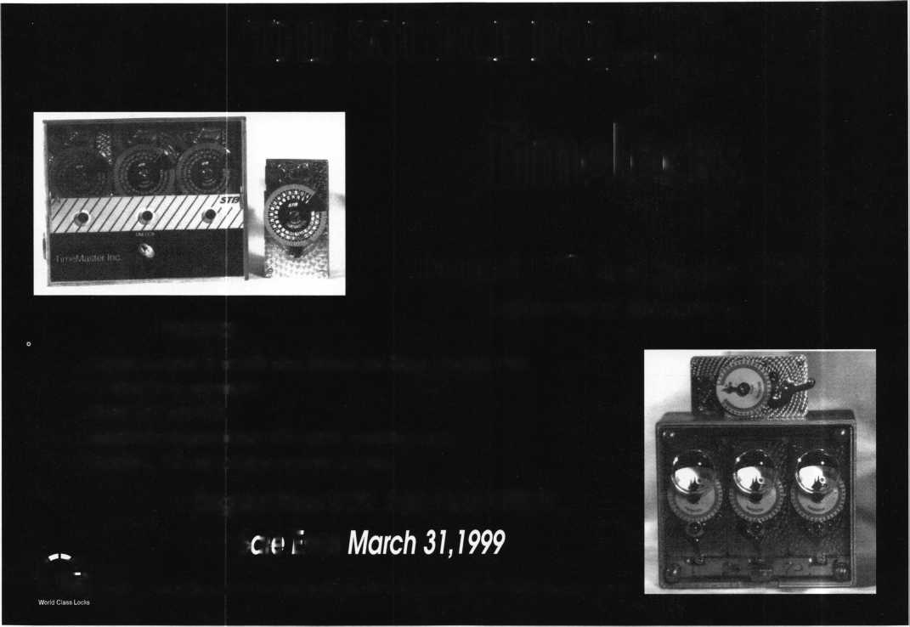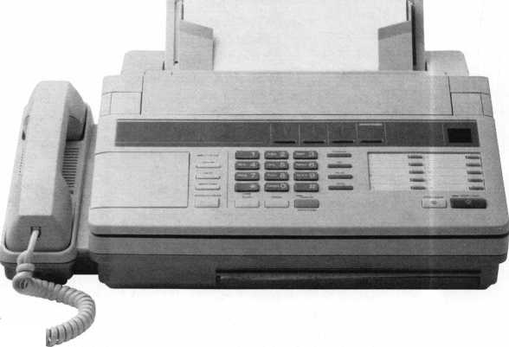

Keynotes

Authors



Paul Chandler,

CRL, is the manager of the Electronic  
Security Department for I.D.N. -  
ACME in Houston, TX. He was  
also “Keynotes Author of the Year”  
for 1998.

Raymond DAdamo, CML has been writing technical artides for Keynotes and teaching automotive locksmithing since 1982.

Tina DAdamo, CRL began lock- smithing in 1983 and immediately showed a great interest in motorcycle locksmithing. She soon realized the lack of motorcycle lock service informa­tion available to locksmiths, and began compiling her own, hoping to someday release it to locksmiths in the form of articles like those in this series.



Mike Emery is the

Editor tf/Keynotes and a freelance  
music, film and real estate ivriter.

Mike Eerrill is a third generation locksmith, who lives on the Island of Nantucket in Massachusetts.



Tim McMullen

oversees legislative affairs for ALOA.  
He is a graduate of the District  
of Columbia School of Law and  
has an extensive background in  
legislative work.

I Sal Dulcamaro,

CML, has been in the locksmith  
business for over 23 years. He is the  
president of All Pro Security, Inc. in  
Michigan and has been an ALOA  
member for 16 years. A past president  
of the Locksmith Security Association  
of Michigan, Sal currently serves as  
editor of the association newsletter. He  
was named “Keynotes Author of the  
Year” for 1996 and 1997.

INTERCHANGEABLE  
CORE PRODUCTS

Interchangeable with: :

• BEST

•ARROW

•FALCON

Quality • Price Delivery

That's what KSP is all about!

KILLEEN SECURITY  
PRODUCTS

Ask your wholesaler about  
our drop shipping•

***33 Hermon St.  
Worcester, IRA 01610  
Phone (508) 798-3200  
Fax (508) 753-2183***

Training

Certification

For a FREE VATSmith information packet and  
locations of BWD Certified VATS Centers  
Cali

**.** 800**-**647-4926

y i See us at [www.alllock.com](http://www.alllock.com)

February 1999

Keynotes

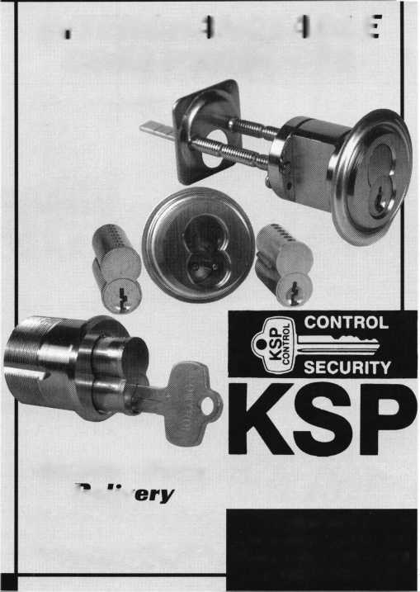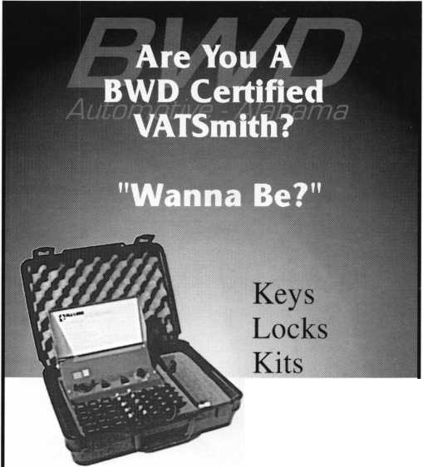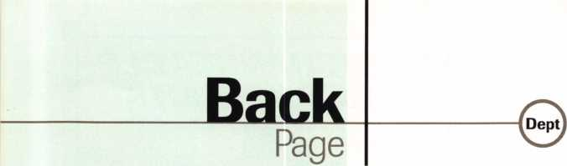

"IBI|,”~4L i

X

"imL. ' ■■#1#

**WHHTS YOUR**

TOP FIVE?

l!>

1-1

Where would America be without its Top 10, 5, or 40 lists? Well, Casey Kasem would have been out of a job years ago and David Lettermen would have to resort to even more “Stupid Pet Tricks” to kill airtime.

Let’s face it “Top” lists are great, fun and effective entertainment (even if they are mindless). With that, Keynotes thought it would be fun to see what kind of lists our readers can come up with. In turn for your witticisms and remarks, well give you two free tickets to the ALOA ’99 Awards Banquet!

If it sounds like a good deal to you then send us your Top Five Reasons I Should Go To ALOA ’99 in Cincinnati on the form below, or email them to [keynotes@anet-dfw.com](mailto:keynotes@anet-dfw.com).

Before you do that, here’s an early submission to give you an idea of what we’re looking for:

1. locked myself out of my shop and need ACE classes to get back in.
2. want to party like it’s 1999!
3. I’m hoping to lock myself in a room with ex-Reds’ owner Marge Schotts.
4. I got gypped on the “Two of a Kind” contest last month!
5. left my heart in San Francisco, but will settle for a trip to Cincinnati.

M

TOP FIVE REASONS

WHY I SHOULD GO TO ALOA ’99 IN CINCINNATI...

Name :

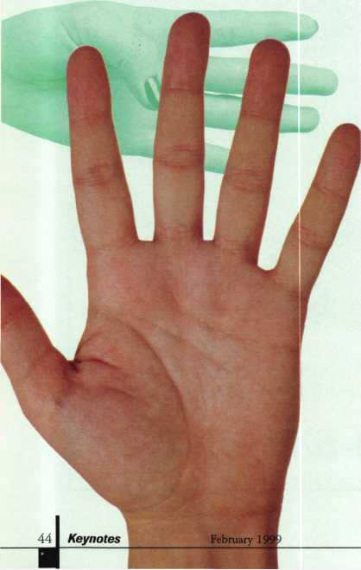

Daytime Telephone Number:

My Top Five Reasons...

1.

**2**.



Mail, fax or email your responses to:

TOP FIVE

c/o **Keynotes** 3003 Live Oak Street Dallas, TX 75204 (214) 827-1810 fax [keynotes@anet-dfw.com](mailto:keynotes@anet-dfw.com)

**nd my subscription to** Locksmith Ledger International

PleaseQ start

* 3 YEARS (includes 36 issues, 3 FREE Annual Directory* issues)

USA $90.00

* 2 YEARS (includes 24 issues, 2 FREE Annual Directory* issues)

USA $64.00Canada $91.00International

* 1 YEAR (includes 12 issues, 1 FREE Annual Directory* issue)

USA $38.00Canada $52.00

International (surface) $119.00

International (surface) $65.00

International (air) $95.00

ISSUE

• Comprehensive guide to industry manufacturers, distributors, products and services.

**CARD INVALID UNLESS COMPLETE DATA IS GIVEN**

You must indicate your locksmithing affiliation below

1. Are you a locksmith or an individual involved in locksmithing? □ YES □ NO
2. My position is: □Owner/Pres. Q3 Employee Q6 Student D9 Other
3. Business classification (check one only): A □Locksmith Shop B □Hardware

C □Wholesaler/Distributor D □Manufacturer E □Security or Maintenance  
1 □Consultant 3 □Industrial 5 □Government  
2□Commercial ^Institutional 6QPolice  
G □Architect/Specifier Z □Other (specify)

1. Are you involved in purchasing or influencing the purchase of locksmith products?

□ YES QNO

**Send payment to: Locksmith Publishing Corp. * 850 Busse Highway • Park Ridge, IL 60068  
Phone: 847-692-5940 • Fax: 847-692-4604 • Website: [www.lpc.simon-net.com](http://www.lpc.simon-net.com)**

Name

Company

Address

CityStateZip PhoneFax

Payment: (US FUNDS ONLY) Money OrderCharge CardCheck #

Complete for Charge Orders Only: VISA Master Card

Account #Exp. Date

Signature

IM8

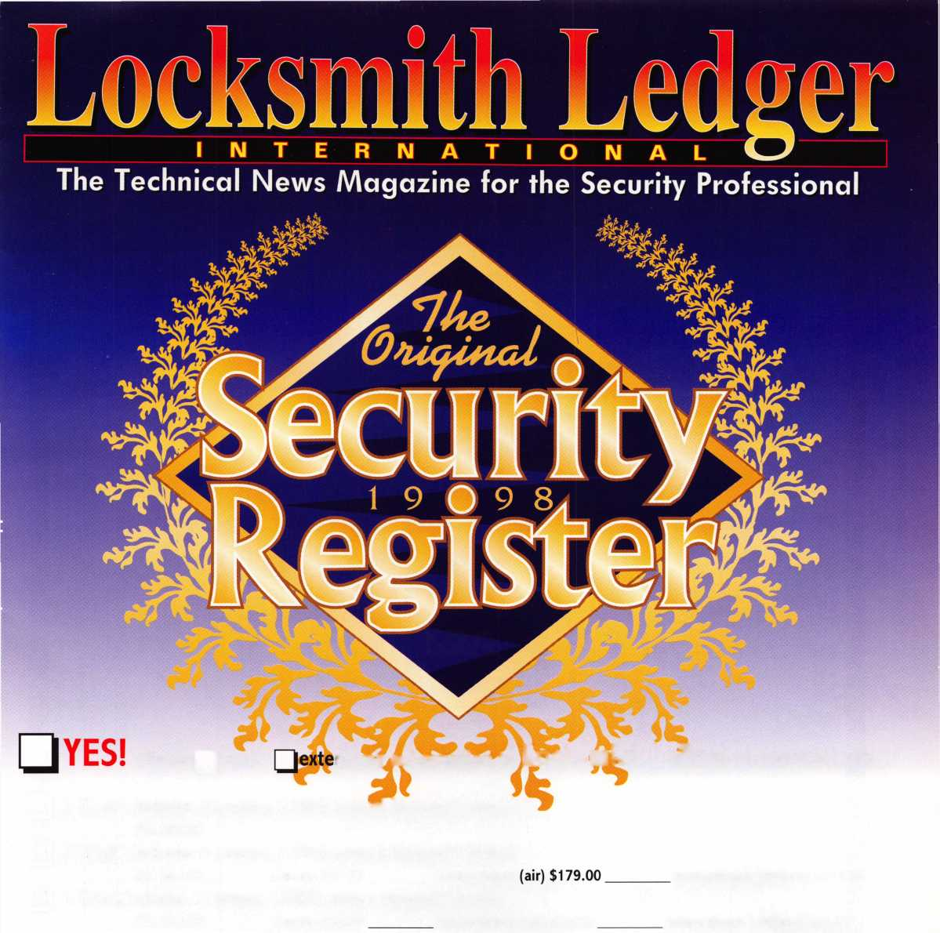

**JULY 2 5 — 31**



Into classes, into networking,  
into the latest products.

This year, don't miss the best  
locksmithing trade show and education  
event of 1999-the ALOA Convention  
and Security Expo. Discover the city  
that boasts Fountain Square, riverboats,  
water parks and a breathtaking  
river view from Mt. Adams.

See you at the pool (the talent pool).

For more info, call 800.532.2563  
or check out [www.aloa.org](http://www.aloa.org)